THE DYNAMIC BODY

This version of the workbook is not designed as a textbook on musculo-skeletal medicine. It is intended as a supplement to the notes you will have made throughout the course. All the handouts that used to be distributed at the end of the lectures have been incorporated plus some comments about most of the problem cases – some more detailed than others. There are extensive hyperlinks to more detailed articles around many of the topics. These are correct at the time of writing but inevitably will change over time and you may have to use your initiative and Google to track them down if they change

Finally thank you for the feedback you added to your evaluation forms.
This gave us lots of information to aid planning future courses and I have not included another evaluation form with this workbook.
However it would be helpful if you could give us feedback on the value of the workbook – both before and after the course
(email preferred) a.dunbar@yorkshiredeanery.com
Adrian Dunbar
September 2005

The core curriculum for the course is based on the GP registrars learning guide in musculoskeletal medicine which you can access and download from:
http://www.arc.org.uk/about_arth/opubs/6311/6311.htm

RE-COURSE WORK

NOTES ON THE SHOLDER

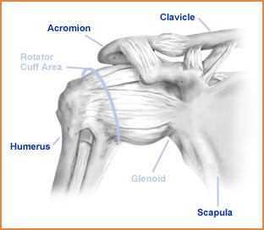

Understanding of the structure and function of the shoulder is essential to the effective management of shoulder problems. Between now and coming to York we suggest you get the old clinical anatomy books out and do a little revision.

The human shoulder is a wonderful structure. Presumably developed for swinging through the trees many years ago it has a huge range of movement which allows the upper limb to perform a huge range of activities. Firstly we need to consider its anatomy. Here is a very basic description - we will amplify this on the course.
The shoulder complex consists of the gleno-humeral joint (GHJ), the acromio-clavicular joint (ACJ), the sterno-clavicular joint (SCJ) and the non-articular scapulo-thoracic joint. All these joints contribute to shoulder and arm movement to a variable degree.
The gleno-humeral joint is a ball and socket joint - the ball is large and the socket is small and very shallow thus allowing a large range of movement. This is, however, at the expense of bony stability.

Stability of the gleno-humeral joint is dependent on the integrity of the soft tissues. In order of importance these are:
- The rotator cuff muscles
- The ligaments of the joint capsule
- The glenoid labrum

The rotator cuff consists of four muscles which act synchronously to provide a functional anchor for the gleno-humeral joint. The four muscles are:
- Supraspinatus which originates above the spine of the scapula and inserts on the humeral head superior to the GHJ and its prime function is to abduct the shoulder.
- Infraspinatus which originates below the spine of the scapula and inserts on the humeral head posterior to the GHJ and externally rotates the shoulder in combination with –
- Teres Minor which originates on the inferior surface of the scapula alongside
- Subscapularis. Both are inserted anterior to the GHJ and internally rotate the shoulder
These separate muscles fuse into a cuff that envelops the humeral head restraining it in the glenoid fossa but facilitating a huge range of movement.

The ligaments are little more than thickenings of the joint capsule. The capsule itself is relatively lax and can be distracted passively to 2.5cm. Laxity is important to allow for the range of movement the GHJ can perform. This is important in a condition called adhesive capsulitis where contraction of the joint capsule can dramatically restrict the range of movement - the “frozen shoulder”. The anterior thickenings are called the gleno-humeral and coraco-humeral ligaments.

The glenoid labrum, a ring of cartilage around the glenoid fossa, deepens the glenoid cavity and provides a “suction force” to anchor the humeral head. (Remember the rubber tips to the arrows you used to fire with your bow when you were a little younger?)

The major “power muscles” or prime movers of the shoulder are Pectoralis major a powerful adductor and internal rotator, Deltoid an abductor and Latissimus dorsi which adducts, internally rotates and extends the GHJ.

The rotator cuff muscles are small and compared to the “prime movers” of the shoulder joint are relatively weak. In some movements (eg abduction) the prime mover (deltoid) would pull the humeral head out of the socket were it not for the co-ordinated contraction of the rotator cuff muscles. If the prime movers become much stronger (training) or the rotator cuff muscles weak (injury) the gleno-humeral joint may become unstable.
The muscles attaching the scapula to the chest wall provide stability to the shoulder by controlling the position of the glenoid.

Above the rotator cuff muscles are the arch of the acromion and the acromioclavicular joint. The space beneath the bony arch is called the sub-acromial space and contains a bursa (sub-acromial bursa). The top of the rotator cuff - the supraspinatus muscle and its tendon cross the floor of the subacromial space. This is a very important area in shoulder injury and you should study the anatomy of it a little before coming to the course.

Some usesful websites:

www.scoi.com/sholanat.htm
www.orthoneuro1.com/patiented/ shoulder.htm

NOTES ON THE KNEE
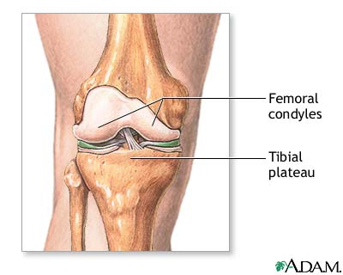
The knee is the largest joint in the body. It is the most commonly injured joint in sport and commonly injured in many other activities. Knee problems are very common in GP surgeries and effective diagnosis and management starts with knowledge of the anatomy. Please continue to refer to your old anatomy books.

From the anatomical point of view there are a number of important features to the knee joint.

The knee is a hinge joint but it is a hinge which allows for a small amount of rotation. Control of the small amount of rotation and uncontrolled, excessive rotation are important factors in knee injuries.

The knee has no bony stability, the rounded contours of the femoral condyles rest on the relatively flat tibial plateau. On the tibial plateau the wedge shaped, semi-lunar menisci increase the load-bearing surface area for the femoral condyles. The menisci bear up to 80% of the load passing through the knee and long term problems arise in the absence of the menisci (if they have been removed following trauma – more of this later)

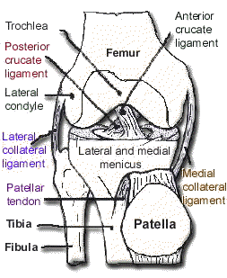
Stability is provided by the collateral and cruciate ligaments, which allow the joint to hinge and rotate slightly, and the adjacent musculature.
The collateral ligaments prevent valgus and varus movement in full extension, the medial ligament also prevents valgus stress in the outer range of flexion. The cruciate ligaments located centrally in the joint prevent excessive rotation and antero-posterior movement.

The muscles acting around the knee are very important for the stability of the joint. Anteriorly the large quadriceps muscles insert via the patella and patella tendon into the tibial tuberosity. Their contraction extends the knee joint. Posteriorly two hamstring muscles (semi-membranosus and semi-tendinosus) are inserted via the pes anserinus winding around the postero-medial corner of the tibial head into the antero-medial tibia. The other hamstring muscle (biceps femoris) inserts on the head of fibula. The hamstrings flex the knee.
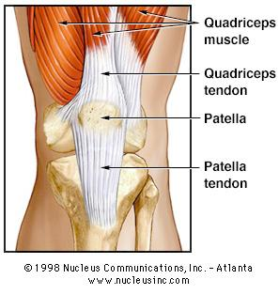
The patello-femoral joint (PFJ) is the largest sesamoid joint in the body and acts as an extension pulley for the quadriceps muscle. The tracking of the patella in the intercondylar groove as the knee flexes is mainly controlled by the balance between the medial and lateral components of the quadriceps muscles (vastus medialis and vastus lateralis). This is very important in the development of anterior knee pain and therefore its treatment. (See notes on anterior knee pain)

: www.hipsandknees.com/ knee/kneedisease.htm
: www.ergonext.com/aa-bodyworks/ leg.htm

NOTES ON THE SPINE
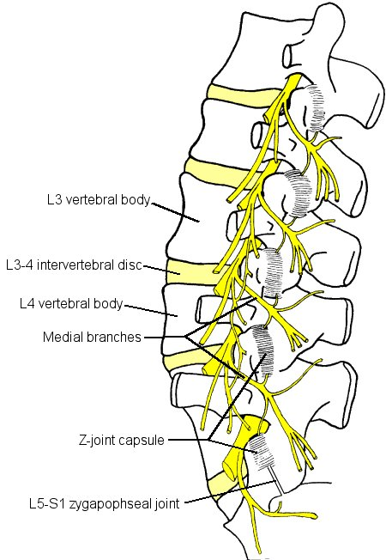
Back pain is one of the biggest health problems in civilised societies. It is one of the commonest problems to present to the GP. Back pain has, in the past, been badly managed resulting in large numbers of chronically disabled people. Fundamental to the understanding of the problem of back pain is knowledge of the structure and function of the spine. Here is a simple outline of the structure of the spine. We will expand on this in the course but in the meantime have a look in your anatomy books and do some revision.

The spine is a column of 24 vertebrae and the sacrum separated by 23 intravertebral discs. The uppermost vertebra (atlas - C1) articulates with the occipital bone of the skull - the lowermost (L5) articulates with the sacrum which in turn is connected to the two halves of the pelvis by the sacroiliac joints.

The vertebrae are linked by intersegmental muscles and ligaments. The anterior and posterior ligaments run the length of the vertebral bodies and the ligamentum flavum connects the spinous processes.

The intervertebral discs bind the vertebral bodies together. Like the vertebrae themselves they increase in size descending the spinal column. The discs consists of the soft central nucleous pulposus surrounded by the tough outer fibrous laminar layers.

On the posterior aspects of the vertebrae, on either side of the spinous processes, are the facet joints. These are a chain of synovial joints where the vertebrae articulate with their neighbours above and below. The alignment of the articular surfaces of the facet joints at each segment determines the direction of movement of that segment. For example the thoracic spine has vertical articular surfaces which allow rotation but relatively little flexion extension. What is the situation in the lumbar and cervical spine? The thoracic spine has vertebrae with large transverse processes to allow for attachment of, and articulation with, the ribs - the costo-vertebral joints.

Between the vertebrae is a canal through which nerves exit the spinal cord. In simple terms nerves passing between the cervical vertebrae supply the upper limbs, the thoracic spine supplies nerves to the viscera and autonomic neural system and the lumbar spine supplies nerves to the lower limbs. Spinal problems which impinge on nerve roots can therefore cause symptoms in the areas supplied by these nerves. This will be dealt with in more detail on the course.
The cervical vertebrae also carry the vertebral arteries to the brain.

The abdominal muscles are not often thought of as part of the spine. They are, however, very important structures in relation to spinal function. They act like a corset and protect the lumbar spine from excessive loading, restricting the range of movement during load bearing.
Intersegmental muscles provide postural stability.

Here are some useful anatomy sites:

www.scoi.com/spinanat.htm
www.chiro.org/chimages/ diagrams/
http://www.back.com/anatomy-lumbar.html

FUNDAMENTAL FOOT ANATOMY
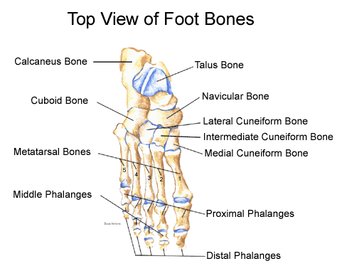

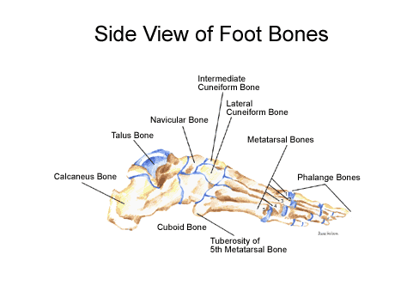

Major Joints
- Ankle joint. Comprised of the mortice (provided by the tibia & fibula), and talus. Ligamentous support primarily on the medial and lateral aspects of the joint. Provides motions of plantar and dorsiflexion.
- Subtalar Joint. Comprising pof the articular facts between the superior surface of the calcaneum and inferior aspects of talus. Primary motion is that of pronation and supination.
- Midtarsal joint. Comprising of the articulations between the talus and navicular and calcaneum and cuboid bones. Provides an axis about which the forefoot can invert and evert upon the rear foot independently.
- Joints of the lesser tarsus
- Metatarsophalangeal joints.

Major structures entering the sole of the foot
Major structures entering the medial side of the foot, behind the medial malleolus
- Tibialis Posterior tendon. Attaches in the medial aspect of the navicular.
- Plays a major role in support of the inner longitudinal arch, and supination of the foot.
- Flexor Digitorum Longus tendon divides into 4 slips one passing into the plantar aspect of each toe.
- Tibial artery and nerve. Major artery and nerve supply to the sole of the foot. Tibial nerve provides motor supply to the intrinsic muscles in the sole and skin on the sole of the foot.
- Flexor Hallucis Longus tendon. Plantar flexor of the big toe.
All the above are held down by the flexor retinaculum attached to the tip of the medial malleolus and the medial aspect of the calcaneus.

Deltoid ligament provides much stability to the medial aspect of the ankle.

Major structures entering the lateral side of the foot, behind the lateral malleolus.
- Peroneus brevis tendon passes rind the malleolus to insert into the styloid process at the base of the 5th metatarsal. Strong everter of the subtalar joint.
- Peroneus Longus tendon. Passes with peroneus brevis proximally then passes under the groove in the cuboid bone on the plantar aspect to insert in the plantar region of the base of the 1st metatarsal, medial cunieform and navicular.
- Both secured in position by the peroneal retinaculum (superior & inferior elements)
- Ankle joint supported laterally by lateral ligaments running from the fibula to the talus (anterior and posterior), and calcaneus (inferior).

Major structures entering the posterior aspect of the foot.
- Achilles Tendon. Inserts into the posterior aspect of the calcaneum. Tendon has incomplete sheath. Protected on its deep aspect by a bursa and fat pad.
Major structures entering the anterior aspect of the foot.

As viewed from medial to lateral
- Tibialis anterior tendon. Inserts into region of the tuberosity of the navicular. Assists Tib Post in support of the arch. Dorsiflexes the ankle joint and inverts the foot.
- Extensor Hallucis Longus Inserts into hallux providing dorsiflexion.
- Extensor digitorum longus. Divides into 4 slips, one inserting into the dorsum of each lesser toe. Providing dorsiflexion.
- Peroneus tertious. Small muscle, tendon inserts with peroneus brevis into the styloid process on the 5th metatarsal base.
Above structures are secured by the extensor retinaculum

Plantar structures
- Fat pad lies deep to the skin over the forefoot and heel
- Plantar Fascia. This is the first major structure to be identified on the sole of the foot. It runs from the anterior aspect of the weight bearing calcaneus,- mainly the medial tubercle, passes forwards as a strong fibrous band before splitting into 5 slips each passing into the plantar aspect of a digit. Acts as a strong tie beam across the arch of the foot.
- Intrinsic muscles of the sole. Found in 4 layers often inserting or arising from the long flexor tendons or metatarsal shafts in the case of the deeper muscles.
- Short and Long plantar ligaments. Support the bones of the tarsus.

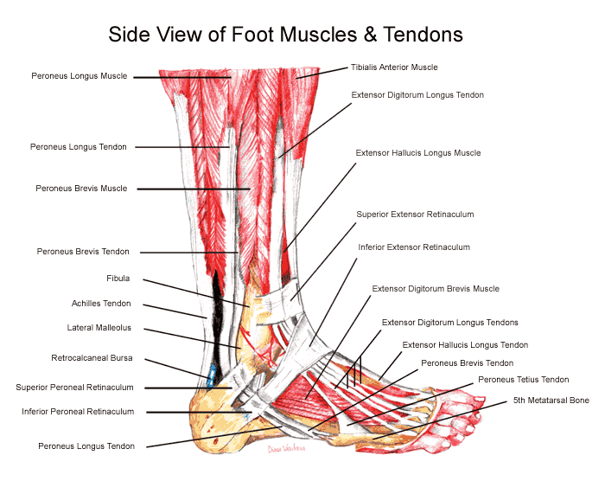

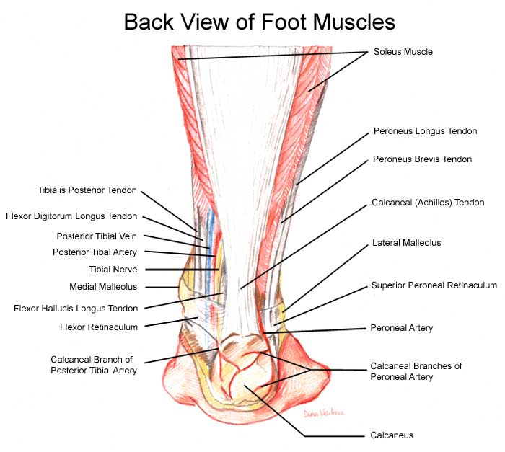

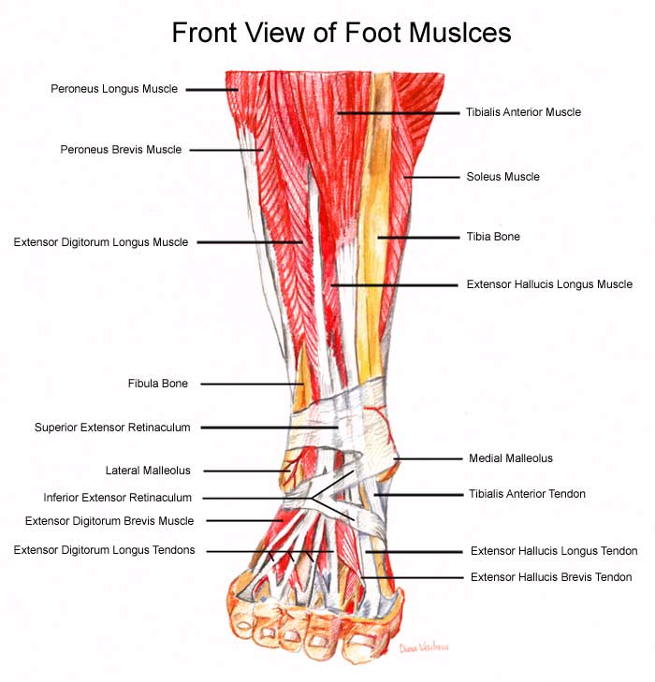
www.drfoot.co.uk/anatomy.htm

NOTES ON MUSCULOSKELETAL INJURY
The course will concentrate on concentrate on common “activity-related” disorders of the musculo-skeletal system - as opposed to the more glamorous chronic inflammatory diseases of the rheumatologists and the more spectacular fractures of the orthopods and traumatologists. In other words the kind of problems that patients bring to their GP.
These are the acute and chronic injuries of the soft tissues and degenerative change relating to wear and tear and the ageing process. We will start by looking at the mechanisms of soft tissue injury and repair.
- Acute injuries -- what happens? - bleeding - clot - collagen - remodelling - good as new. - Time scale - depends on blood supply and stresses - these can be influenced by treatment - ice and specific exercise.
- Chronic injury - repeated acute trauma - can lead to scar formation - what is the effect of scar formation? - shortening - loss of elasticity / flexibility - ?impingement? - high risk of re-injury. Treatment aims at removing (helping the body to remove) scar tissue.
- Overuse injury - the normal response of a soft tissue to a “training load” is to grow and strengthen. Overload leads to microscopic soft tissue damage - (pathology is outwith the scope of this course) - if allowed repair and renewal occurs resulting in a stronger tissue - if further overload is applied before repair is completed further microtrauma occurs - with time cumulative microtrauma leads to macrotrauma, sometimes with chronic inflammation and scar formation. Treatment aims to reduce inflammation - reduce / remove scar tissue - promote healing and prevent recurrence.
- Degenerative change - the dynamic body starts to degenerate at a disappointingly early age - the capacity to heal and repair declines almost as soon as adulthood is reached. Evidence of degenerative change can be found (radiologically) in the early twenties (Osteoarthritis). Degenerating tissues become less vascular, more fibrous, less elastic, muscle are lost, fat accumulates. Regular “training” delays the onset of degenerative change - smoking accelerates - as can injury.
All tissues in the body (except the nervous system) “turnover” - some more than others, the gut and blood cells are examples of tissues rapid turnover. In osteoarthritis the cartilage cell’s capacity to regenerate declines. When the breakdown process exceeds repair capacity then symptoms can develop in joints.
If you really have an interest in the science of this area have a look at:
Osteoarthritis
cartilage breakdown and repair
There are factors which accelerate degeneration and factors which can (to a limited extent) augment repair and these will become apparent later in the course in relation to specific problems.

CASE HISTORIES
The following brief case histories are presented as if they might occur in every day surgery. They have all presented to the course organisers in the past. Please consider what diagnosis (or diagnoses) are suggested by the brief details. What questions would you ask the patient to confirm or refute the diagnostic possibilities? What would you be looking for in your examination. What investigations (if any) are appropriate? Finally what would your management plan include?

The cases presented will form the basis of group discussions during the course. Please try to answer the questions under examination style conditions first. Then having identified your learning needs with respect to the problems please feel free to ask colleagues, trainers and consultants for advice. Or, alternatively, read around the problems in appropriate texts listed below.

Reading list:

Orthopaedics in Primary Care 1997 ed. Andrew Carr & Anthony Harden Butterworth-Heineman

Rheumatology for General Practitioners ed H L F Carey & Sally Hull Oxford University Press

Back Pain: Recognition and Management 1993 M A Hutson Butterworth-Heineman

Work-Related Upper Limb Disorders 1997 M A Hutson Butterworth-Heineman

ABC of Rheumatology BMJ Books

ABC of Sports Medicine BMJ Books

ABC of Work-Related Disorders BMJ Books

Illustrated Manual of Orthopaedic Medicine Cyriax

Clinical Sports Medicine 1993 Peter Bruckner & Karim Khan McGraw-Hill

Collected reports on the Rheumatic Diseases ed Robin Butler & Malcolm Jayson Arthritis and Rheumatism Council for Research

Alternatively you may like to browse the following excellent websites
http://libraries.nelh.nhs.uk/musculoskeletal/
www.arc.org.uk
(use the site index or look at publications for professionals to find Synovium

Each year more evidence is accumulated to support or refute treatment modalities in musculo-skeletal medicine. Increasingly we are referring to the Cochrane database for definitive statements on the quality of evidence to support the treatment methods we discuss. http://www.nelh.nhs.uk/cochrane.asp
Each year more evidence is accumulated to support or refute treatment modalities in musculo-skeletal medicine. Increasingly we are referring to the Cochrane database for definitive statements on the quality of evidence to support the treatment methods we discuss.
www.nelh.nhs.uk/cochrane.asp

NECK PROBLEMS
Neck pain is common in primary care. Estimates vary between 21 and 76% of populations experiencing neck pain at sometime in their lives. Other figures give a point prevalence of 9% of men and 12% of women having neck pain. The RCGP gives and annual incidence for the UK of 12.1 per 1000 patient years. Associated disability occurs in 15% and severe disability in 5%. Neck pain is costly comprising 15% of physiotherapy referrals and 30% of chiropractic visits. In some populations neck pain is as common as low back pain as a diagnosis in work-related sickness absence. In motor vehicle accidents 24 – 50% of patients report persistent neck pain at 12 months. So our first patient is very appropriate.
- A 25 year old lady presents in surgery with a sore neck. Yesterday whilst stationary at traffic lights her car was hit from behind by a large truck. She was not injured in the incident but has woken this morning early with severe pain and stiffness in her neck.
You will immediately be thinking of the word whiplash.
What is Whiplash?
Whiplash is a soft tissue injury to the neck. It was first described, many years ago as “railway spine” but today most commonly occurs after a road traffic accident in which there is sudden extension and flexion of the neck – this is nearly always the rear end impact. Other structures may occasionally be injured but characteristically it is a soft tissue injury. Neck pain and stiffness typically take several days to develop with relatively little discomfort immediately after the impact. Immediate pain suggests more severe injury and merits immediate evaluation. Other symptoms may include headache, dizziness, abnormal sensations such as burning or prickling (paresthesias), or shoulder or back pain. In addition, some people experience cognitive, somatic, or psychological conditions such as memory loss, concentration impairment, nervousness/irritability, sleep disturbances, fatigue, or depression.
Is there any treatment?
Treatment for individuals with whiplash should include effective analgesia, local heat, non-steroidal anti-inflammatory drugs, antidepressants, muscle relaxants, and a cervical collar (caution re duration of use). Range of motion exercises, physical therapy, and cervical traction may also be prescribed.
What is the evidence?
Quoting the Cochrane database:
It appears that "Rest makes rusty." In other words, rest and immobilization using collars are not recommended for the treatment of whiplash, while active interventions, such as advice to 'maintain usual activities' might be effective in whiplash-patients. Nevertheless, caution is needed when attempting to draw conclusions regarding the efficacy of conservative treatments in whiplash-patients, because of the paucity of high-quality studies. No conclusions can be drawn about the most effective therapy for chronic whiplash-patients because only one low quality trial was identified.
What is the prognosis?
Generally, prognosis for individuals with whiplash is good. The neck and head pain clears within a few days or weeks. Most patients recover within 3 months after the injury, however, some may continue to have residual neck pain and headaches. As with other musculo-skeletal injury consider “yellow flags” and address them appropriately. More on yellow flags later.

“Hot off the press”
Whiplash - more than a pain in the neck
A paper from Alberta in Canada published in the Annals of the Rheumatic Diseases challenges us to think of the illness reported after motor vehicle collisions as a systemic condtion.
The study examined data from a large population based cohort of individuals making an insurance claim over an 18 month period, and included collision related data, pre-collision health data, symptom prevalence and scores on the short form 36 item general health survey (SF-36), within one month of collision.

Approximately 3500 patients who met the criteria for whiplash injury completed the SF-36. Neck pain was only one of many diffuse and intense symptoms. The range of symptoms included fatigue, cognitive problems, tinnitus, dizziness, paraesthesia – in upper and lower limbs, headache, spinal pain, nausea and jaw pain. The SF-36 showed low physical and mental functioning one month post-collision.

The authors conclude, that what is commonly referred to as whiplash associated disorders (WAD) is best appreciated as a syndrome extending well beyond what can be labelled as a neck injury.

These findings will concur with many practitioner’s experience in managing sufferers of whiplash injury. Some are straightforward and recover quickly; others go on to a chronic multifaceted illness. In a statement not dissimilar to our current understanding of chronic fatigue syndrome, the authors suggest that WAD “should not be viewed piecemeal, as a series of specific structural disorders but as a more generalised illness, involving diverse symptoms reflecting pathology, psychological responses and the social context in which the illness occurs”.
This provides encouragement to practitioners to manage WAD in a more holistic fashion, providing explanations and reassurance, advice to remain active, advice that pain does not equate with damage and focussing on active coping rather than passive waiting for healing as a more helpful strategy than specific medical treatments.

Ferrari R, Russell AS, Carroll JD &Cassidy JD. A re-examination of the whiplash associated disorders (WAD) as a systemic illness Ann Rheum Dis; 64: 1337- 1342

- Joanne, an 18 year old student, woke up this morning and whilst getting out of bed had a sudden pain in the right side of her neck and her neck seems to have seized up with her head turned to one side.

Acute torticollis or wryneck is common presentation in primary care. The problem is self limiting and advice about self-management with heat, rest and analgesia is all that is required whilst waiting for the problem to resolve. The pathology is thought to be either an acute tweak of cervical disc or a “locked up” facet joint. There appears to be no value in discovering the pathology. Muscle spasm is the main feature and symptomatic treatment is appropriate.

- A 72 year old man presents with a “stiff neck”. There is no history of injury. He has noticed that his pain is particularly severe when he turns his head to the right when driving his car.
This appears to be a descripion of mechanical neck pain and the words wear and tear or cervical spondylosis are often used.
What Should be Done for the Patient with Neck Pain (X-Rays Show Cervical Spondylosis)?
There are parallels here to mechanical low back pain of which there will be very much more later.
The incidental mention of migraine reminds me that many patients with a susceptibility to migraine and a musculo-skeletal problem find their headaches are worse when their joints are sore and relieved when their joints improve.
Advice to take simple analgesia, use local heat, to maintain range of motion with gentle mobilising exercises and a patient information leaflet ARC neck pain leaflet for patients should form the basis of management.
In some patients with chronic neck pain – posture – especially work related posture – think PCs and workstations or driving may be a factor in the origin or maintenance of their symptoms. More of this in the session on occupational injuries.
Finally to quote the Cochrane database again:
A large variety of therapeutic interventions are available for the treatment of mechanical neck pain. There is little definitive knowledge as to which rehabilitative conservative management strategy or therapy combination is most effective in the treatment of acute or chronic cervical pain. Exercise therapy is a widely used treatment. In the last systematic review, the effect of exercise therapy on neck pain was inconclusive lack of conclusive evidence and the addition of new trials since the last systematic review support the need for a systematic update.

Two further articles on the evaluation and management of neck pain
http://www.physsportsmed.com/issues/1996/10_96/aptaker.htm
http://www.physsportsmed.com/issues/1996/11_96/aptaker2.htm

SHOULDER PROBLEMS
- Mrs Jennings, a 75 year old lady had a fall 3 weeks ago. She fell forwards onto her right hand. She had immediate pain in the right shoulder and it seems to have got stiffer and more painful since. She is unable to sleep on that shoulder at night. She cannot comb her hair or fasten her bra strap because of severe pain associated with those movements.
First of all you would want to exclude the possibility of an unreported fracture here, unlikely though this would be to present some three weeks later with a progressive increase in symptoms.
The history of relatively mild immediate symptoms with progressive increase in pain and loss of function suggests a soft tissue injury with an inflammatory origin. Absence of deformity – lack of bruising and swelling at the time and absence of a specific area of bony tenderness should increase your confidence that there is unlikely to be a fracture. If any of these features were present you may want to arrange an X ray or fracture clinic review.
The history here however is of a rotator cuff in jury.
Rotator cuff injuries
Rotator cuff lesions are very common in patients presenting to their GP with shoulder pain and appear commoner in the more mature patient – presumably reflecting the role of degenerative change. In addition to falls onto the outstretched hand, rotator cuff lesions occur in sports where vigorous, overhead activity is a feature – the throwing sports, racket sports and swimming (front crawl and butterfly).
Direct trauma, as in the fall on the outstretched hand results in the superior segment of the rotator cuff – the supraspinatus tendon being crushed between the humeral head and the underside of the acromion.
In overhead activity a complex combination of factors can lead to similar though more chronic rotator cuff injury due to impingement.
It is important to differentiate rotator cuff problems from the frozen shoulder syndrome (adhesive capsulitis) which is not an injury. See case number 5 below.
Management of the problem, in the case of the acute traumatic injury is relatively simple. Simple anti-inflammatory medication is often effective but in the elderly patient can have significant and serious side effects. An injection of steroid into the subacromial space above the rotator cuff is simple, safe and very effective treatment. When the painful symptoms start to settle after a couple of weeks your friendly physiotherapist will advise on a programme of exercises to strengthen the muscles that will have weakened as a result of the injury. Rehabilitation is essential before return to sport is considered. Neglecting the rehabilitation will inevitably lead to high risk of early recurrence of the injury.
With chronic, overuse, injury to the rotator cuff rehabilitation must include attention to the causative factors and their elimination.

- A 24 year old man presents with chronic shoulder problems. He dislocated the shoulder playing rugby 2 years ago and says it has never been right since. He has not played rugby since the injury. He did try swimming and weight training to strengthen the shoulder but describes the arm going "dead" on occasions. He describes a couple of episodes where he felt the shoulder almost "went out" again. Once when he was throwing a ball to some children in the park and once when he tried to play tennis.
This is a typical history of an unstable shoulder following anterior dislocation. Without supervised rehabilitation he has strengthened his power muscles and neglected the stabilisers – the rotator cuff. He needs a rotator cuff rehab programme such as you have heard from Richard.

- A 60 year old lady has a long history of shoulder problems. An Xray report in her records from 2 years ago notes, "Severe degenerative change in the glenohumeral joint and an acromial osteophyte". Today she appears to have a painful arc of abduction. She says she has had this twice before and has had some benefit from a "cortisone injection".
As we discussed this is not a good shoulder. The primary problem is the degenerative glenohumeral joint. The second problem is the recurrent impingement on the rotator cuff of the sub-acromial osteophyte. Management options include continuing to inject the subacromial space for symptomatic relief. With the development of “key-hole” surgery the option of shaving off the acromial osteophyte is now much less of a traumatic procedure and increasingly attractive.

- Dennis is a 55 year old farmer who presents with well localised pain at the top of his right shoulder. The pain disturbs his sleep at night – when he lies on that side. He has also found the pain is very much aggravated at work by pushing against a heavy object (a cow!), reaching up to grab a rope that was hanging above him and also when he reaches across to touch his opposite shoulder
Pain that is well localised to the tip of the shoulder is strongly suggestive of acromio-clavicular joint pathology.
Acromio-clavicular joint injuries
In contrast to pain from the rotator cuff, which is more diffusely felt, pain from the acromio-clavicular joint (ACJ) is felt immediately over the joint. Chronic problems with the ACJ are common in shooters – due to the recoil from the shotgun on the clavicle, and in weight lifters due to their inclination to perform bench presses and the like, with very high weights. Bench presses are performed laying on a bench pushing up a bar loaded with pig iron. They develop the pectoral muscles, which are popular with bodybuilders and young men seeking to impress young ladies with their manly chests. They also put enormous strain on the ACJ as the bar is lowered. More acute injuries occur traumatically with falls onto the point of the shoulder, as opposed to the outstretched hand. Rugby players often fall onto the point of their shoulders when tackled due to a reluctance to let go of the ball under their arm. Rugby players often present with acute ACJ injuries. Both acute and chronic injuries that are clearly inflamed respond well to intra-articular steroid and refraining from the causative activity. The ACJ is easily injected, lying superficially under the skin and far from any significant structures that should not be impaled by a needle.
Chronic injuries – especially if OA is present, that fail to respond to conservative treatment or keep returning despite modification of activity, may be referred to your friendly shoulder surgeon. Excision of the distal centimetre of the clavicle is very effective in relieving symptoms and, very surprisingly, has little adverse effect on joint function.

- .Whilst attending for review of his cardiac medication Sydney, a 58 year old retired nurse, mentions pain in his left shoulder. The onset was very gradual and he has found he has gradually lost the range of movement in his shoulder.
This history is strongly suggestive of adhesive capsulitis or the frozen shoulder.

Adhesive Capsulitis
In this condition the history is of slowly progressive stiffness and pain, which may follow an injury but often does not. It may be associated with other pathology for example a myocardial infarction or stroke. On examination stiffness of glenohumeral movement is often dramatic. There is a global impairment of the range of movement with external rotation affected most followed by abduction and internal rotation least affected. This is described as the “capsular pattern” of restricted movement. There are no useful investigations here. Diagnosis is based on clinical findings. The pathology is of idiopathic fibrosis of the joint capsule. Fibrosis and contraction predominantly affects the anterior capsule therefore restricting external rotation more than other movement.
Treatment of adhesive capsulitis is much more difficult and often makes little impact on the natural history of the condition. The duration of the syndrome is usually 18-24 months. Treatment is primarily effective analgesia – especially at night as sleep is often disturbed – and with physiotherapy to maintain function whilst awaiting resolution. Manipulation under anaesthesia and steroid injections are often used but evidence of their effectiveness is very thin on the ground.
Further information on Shoulder problems can be found on the ARC site and in the
Dutch College of GPs guidelines:
ARC: Shoulder Problems in General Practice

THE ELBOW
- A 64 year old electrician presents with a painful elbow that has gradually got worse over 6 months. He is now almost totally unable to use a screwdriver as a result of severe pain on gripping tightly.
Tennis Elbow
Tennis elbow is a typical overuse injury of the common extensor origin at its attachment to the lateral epicondyle of the humerus. It is one of those everyday general practice problems that can be remarkably difficult to cure. Treatment is easy - cure is not. The problem with tennis elbow is the patient – and his or her activities. Often sport, occupation and other leisure activities combine in the creation of an injury. If the injury was acquired in a burst of DIY and is not going to be repeated until the next room needs decorating then whatever the treatment modality the outcome is likely to be good. If, however, the problem is the result of an activity that is likely to be resumed as soon as symptoms settle, and then continued all day every day, then the outcome is likely to be less than good - whatever the treatment. Therefore the activity has to be modified. Apart from the obvious reduction in volume and frequency of activity there are things that can modify the biomechanics of the grip. The cause of the problem lies in the tight grip and the repetitive wrist extension – playing the backhand at tennis, but also using trowels and scrapers, screwdrivers and hammers. If a single instrument or tool is used then the size of the grip can be increased. An extra layer of leather or towelling tape around the racket handle can open up the hand a little and reduce the strain at the common extensor origin. Sometimes an epicondylar clasp is helpful. Medical management is much less important than attention to the causative activity and correction of any adverse biomechanics. Any anti-inflammatory treatment can be employed – NSAIDs, ultrasound amd local steroid injection. There is no good evidence that any one treatment is better than another and this needs explaining to the patient when discussing modification of activity.
The Cochrane library currently has a number of systematic reviews of treatments for lateral epicondylitis for your interest:
http://www.nelh.nhs.uk/cochrane.asp - type lateral epicondylitis into the search box and tick systematic reviews then click “GO”
An information leaflet for patients is available from the ARC

- Robert, a 55 year old accountant, presents with a large, soft, painless swelling over his left elbow.
An olecranon bursa if asymptomatic is best left alone to resolve spontaneously
- A 60 year old retired car mechanic presents with bilateral sore swollen elbows.
Red flags – bilateral swollen joints – think systemic disease – investigate and refer
- James (age 14) is brought by his mother with a right elbow that has been sore for months. After cricket practice at school yesterday he experienced a sharp pain in the elbow and finds he cannot fully straighten his arm.
A rarity – osteochondritis dissecans is a curious condition in which a small area of bone undergoes avascular necrosis for no very obvious reason – the dead bone fragment and its overlying hyaline cartilage can detach and act as a loose body in the joint. It needs arthroscopy and removal. The knee and elbow are the two most commonly affected joints. There is anther case later on.
An article on Osteochondritis Dissecans
- Jean is a telephonist at the local hospital. She complains of pain at the medial side of her right elbow which gradually builds up during her shifts at work. – and slowly settles – it is not usually present in the morning before work. Her elbow appears completely normal on examination.
This is just a reminder that sometimes referred pain from higher up can present as a problem lower down – lumbar spine refers to the hip – the hip to the medial side of the knee – the neck to anywhere in the arm. Always consider the possibility of referred pain if the symptomatic structure appears normal on examination. This could be a neck problem

Another article on assessment of elbow injuries

THE WRIST AND HAND
- A 30 year old pregnant lady is being woken at night with painful pins and needles in her right hand and forearm. She has no problems in the day time but is very grumpy through losing sleep.
This is a typical presentation of the carpal tunnel syndrome, of which there are many variations. In this situation the syndrome is temporary – at the end of her pregnancy her symptoms will resolve so you will be considering short term measures to deal with the problem.
Aside from pregnancy there are a number of systemic conditions which can feature carpal tunnels syndrome – what are they?
For a more detailed account visit
http://www.arc.org.uk/about_arth/med_reports/series5/ho/6523/6523.htm

Carpal tunnel syndrome – comments from the Cochrane reviewers
Current evidence shows significant short-term benefit from oral steroids, splinting, ultrasound, yoga and carpal bone mobilisation. Other non-surgical treatments do not produce significant benefit. More trials are needed to compare treatments and ascertain the duration of benefit.
Local corticosteroid injection for carpal tunnel syndrome provides greater clinical improvement in symptoms one month after injection compared to placebo. Symptom relief beyond one month compared to placebo has not been demonstrated. Local corticosteroid injection provides significantly greater clinical improvement compared to oral steroid up to three months after treatment. Local corticosteroid injection does not provide improved clinical outcome compared to either anti-inflammatory treatment and splinting after eight weeks or Helium -Neon laser treatment after six months.
There was no evidence that placebo interventions in general have clinically important effects. A possible moderate effect on subjective continuous outcomes, especially pain, could not be clearly distinguished from bias
Surgical treatment of carpal tunnel syndrome relieves symptoms significantly better than splinting. Further research is needed to discover whether this conclusion applies to people with mild symptoms.
There is no strong evidence supporting the need for replacement of standard open carpal tunnel release by existing alternative surgical procedures for the treatment of carpal tunnel syndrome
An information leaflet for patients is available from the ARC

- A 65 year old man describes his 4th finger on the right hand getting stuck in the bent position but then flicking out if he tries really hard to straighten it.
Trigger finger – best injected with some steroid – injection failures can be excised
- A 60 year old lady describes increasing pain, stiffness and swelling in the base of both thumbs that is exacerbated by housework. She finds wringing out a wet cloth particularly painful.
Washerwoman’s thumb – osteoarthritis at the base of the thumb – best injected with steroid – though not the easiest of injections with a branch of the radial artery close by. Joint replacement may be considered

- A 70 year old man has a painless hard swelling in the lateral side of the palm of his right hand..
Dupuytren’s contracture – surgery is the only effective treatment – this must be timed before the fingers start to contract into flexion to avoid permanent damage to the joints.
- A 42 year old lady has a painless soft swelling on the dorsum of her left wrist
A ganglion may be treated traditionally by whacking it with a large book. If they are not troublesome they are probably best left alone – recurrence is common after excision and excision is not always simple

PROBLEMS WITH THE HIP AND GROIN
- A 40 year old solicitor who is training for the London Marathon complains of pain in his right hip. It is particularly painful getting out of bed in the morning and on hills and stairs. He also has difficulty getting out of the car and is unable to lie comfortably on his right side.

Patients describe pain in their “hip” rather loosely, anatomically speaking, so it is important to ascertain precisely where they are feeling the pain. Pain from the hip joint is felt in the groin and refers down the medial thigh as far as the knee(L2/L3 dermatomes).. This is an important fact to remember when the patient complains of medial knee pain and the knee joint appears normal – check out the hip. Remember also that lumbar spine pain refers to the hip (The groin = L1 dermatome, L2 over the upper buttock and down the lateral aspect of the thigh).
In this gentleman if he complains of pain in the appropriate area, given his age, activity and occupation(!) excluding OA hip is important. OA is more likely if there has been previous injury to the hip joint or if there has been a congenital/developmental abnormality (CDH Perthes SUFE) Family history is relevant too, there is a five fold increase in his risk of OA hip if he has sibling with OA hip.
http://www.arc.org.uk/about_arth/med_reports/series4/ip/6504/6504.htm
Next you should establish exactly which movements and positions cause or aggravate the pain and what if anything relieves the pain. There may also have been an event – something different perhaps about the run during which the symptoms developed. (Link to “things runners do”)This runner had well localised pain over the greater trochanter. His pain started going up a particularly steep hill at a particularly fast pace. Hip flexion to around 90 was painful as was abducting the flexed hip (getting out of the car) Pressure over the greater trochanter was sore (lying on that side in bed). The range of hip joint movement was well preserved and it was possible to be confident about the absence of OA. He was very tender over the greater trochanter especially with hip flexion.
The diagnosis here is trochanteric bursitis. No investigations are necessary, unless OA is suspected.
Trochanteric Bursitis
Inflamed bursae commonly occur around osteoarthritic joints, especially the knee but also the hip. Trochanteric bursitis is a common problem of the long distance runner. The runner presents with hip pain that is well localised to the greater trochanter. Falls onto the hip may cause an acute bursitis
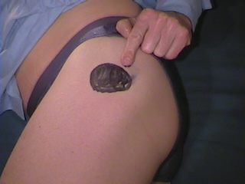

The trochanteric bursa lies beneath the tensor fascia lata and gluteus medius and lateral to the greater trochanter. The biomechanics, predisposing and precipitating factors are similar to the ITB syndrome (see below)- tight soft tissue causing friction over a bony prominence as it passes back and forth approximately 800 times per mile run. Running up to 80 miles a week, as the man training for the marathon may be attempting to do, can create a whole lot of friction.
Management options are essentially the same as for the ITB syndrome with a biomechanical assessment for persistent or recurrent symptoms.

- A 17 year old boy presents with pain in the left groin which has been niggling away for several months. He plays a lot of football for the school and the village club youth team. He feels stiff at the start of a match or training session but it seems to disappear as he warms up. He thinks he has lost a bit of power with kicking the ball but otherwise he feels fine during the matches. Afterwards he rapidly seizes up and is stiff for a couple of days.
The diagnosis here is between an adductor strain and the “sports hernia” or Gilmore’s groin
Read more about the sports hernia
And more on the assessment of groin pain

- A 13 year old girl is brought into surgery from the school across the road. She was playing netball in the playground and experienced the sudden onset of right medial knee pain. She describes grumbling pains in the area for several months leading up to this episode. She is slightly overweight and has recently entered puberty.
Here is another warning about referred pain – the hip can refer to the medial side of the knee – this girl turned out to have a slipped upper femoral epiphysis and was referred to orthopaedics and subsequently underwent a pinning procedure.

KNEE PROBLEMS
- Amanda, 14 year old girl presents with pain around the lower border of the left patella. this is increasingly interfering in all energetic activities. She, and her parents, are rather fed up that her promising season as a cross country runner has come to an abrupt halt.
- Michael is a 48 year old teacher who presents on Monday morning having returned from a weekend of mountain walking in the Lake District. His family having grown up and left home, he and his wife have recently been rediscovering their previous love for long distance walking. As the weekend progressed he found descending steep mountainsides increasingly painful due to pain around both kneecaps. On Sunday a walk had to be curtailed as the pain had become so severe. On the car journey home both knees were very uncomfortable and he had to get into the back of the car to sit with his feet up and knees extended to relieve the pain.
- Stephanie is a 25 year old office worker. She presents with pain around and below her right knee and a locking sensation which occurred last evening at a step aerobics class. She had to leave the class as a result of the pain and this morning she feels the knee has swollen. Her records disclose a note concerning a previous episode when she attended the A&E department: “painful effusion R knee after aerobics, XR normal, FBC, viscosity, urate normal – rest, tubigrip, naproxen”.
These three patients are different presentations of the patello-femoral pain syndrome
Patello-femoral pain syndome
Pain occurring in the front of the knee is very common in primary care and is said by some to be rather like low back pain – i.e. often difficult to relate symptoms to a pathological process. There are many potential causes - acute trauma - repetitive trauma - late effects of trauma. There are common problems like pre-patellar bursitis or Osgood-Schlatter’s disease and rare ones like Hoffa’s syndrome. Patello-femoral arthritis occurs in the more mature patient but these problems usually have obvious features, including physical signs, to lead you to the correct diagnosis. However, in the majority of patients with anterior knee pain it proves impossible to demonstrate pathology.

Anterior knee pain occurs in 30% of adolescents and is commoner in girls, often in both knees and is worse after sport.

Aggravating activities include squatting and kneeling, swimming breast stroke, jumping, descending stairs and steep hills and sitting with flexed knees - driving and the cinema. The cartilaginous articular surfaces of joints are not well supplied with blood vessels and nerve endings. The latter explains the diffuse nature of the pain, which is felt over, around and below the patella, and the gradual or delayed onset of symptoms with activity, especially in the early stages of injury.

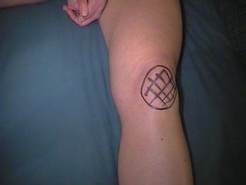
Site of pain in patello-femoral pain syndrome.

Examination is often unrewarding with only tenderness on compression of the patello-femoral joint and around the margins of the patella.
So what is the explanation for the symptoms?
This is a little complicated and involves understanding some biomechanics – but I will try and make it as simple as possible.
First of all you need to remember some simple physics concerning levers. Consider the femur as a lever – where is the fulcrum? – On the tibial plateau. The long lever arm – the shaft of the humerus has, at its end, the entire weight of the upper body. At the other (short arm) end the forces produced by body weight multiplied by femur length are counteracted by the quadriceps contractions and are exerted through the patella and its tendon. The forces generated on the quadriceps/patella in ascending and descending hills and stairs are therefore enormous.

Secondly you need to know something about how muscles work. Imagine holding a 5kg dumbbell in your hand. Roll up your sleeve to watch your biceps in action. Flex your arm to lift the weight and watch your biceps shorten and bulge – does it look impressive? This is called a concentric contraction. Now extend your arm and note how your biceps maintains its contraction whilst extending and the weight is lowered. This is an eccentric contraction. When you step up your quadriceps performs a concentric contraction to lift your body weight and conversely performs an eccentric contraction when you step down to lower your body weight. Eccentric contractions are much harder work for the muscle (don’t ask awkward questions like why? – the answer is outside the scope of this lesson!) and so fatigue occurs earlier.
Thirdly you need to now how the balance of the different components of the quadriceps muscle and other factors influence patella movement in flexion and extension of the knee.

Normally the combined forces of the quadriceps muscle keep the patella in the centre of the intercondylar groove on the distal femur through knee flexion and extension. However, in certain circumstances the patella moves laterally with resulting friction of the posterior surface of the patella on the lateral edge of the intercondylar groove.
There are many potential causes of this “mal-tracking” of the patella. A particularly common situation is the adolescent female growth spurt in which the pelvis widens taking the greater trochanter of the femur with it and increasing the Q - angle at the patella (see above diagram). As the femur lengthens with further growth the Q - angle reduces again and the mal-tracking disappears. Other situations include an imbalance of the different quadriceps muscles with a relative weakness of vastus medialis (which pulls the patella medially correcting the situation in the diagram). This imbalance can occur in many sporting activities where the other quads muscles are developed preferentially to vastus medialis or when vastus medialis becomes more fatigued than the other components of the quadriceps. This latter problem can occur, for example, in unaccustomed and excessive descent of steep hills in the mountain walker or fell runner. Management is therefore mainly a correction of the muscular imbalance with exercises to specifically strengthen and improve endurance in vastus medialis. Temporary relief of symptoms may be achieved by applying tape to the patella to provide a little extra resistance to lateral movement. A physiotherapy referral is therefore appropriate. In the case of the adolescent girl, waiting for normal growth to restore more favourable biomechanics may be all that is necessary.

The patient should modify their activities to allow the symptoms to settle whilst muscular imbalance is being corrected. Avoiding obviously aggravating activities is sensible. Keeping the knee straighter in different activities should be advised - sit next to the aisle in the cinema and extend the knee - raise the saddle on the bicycle to reduce the amount of knee flexion, pedal in easier gears to reduce the compressive forces on the patello-femoral joint.

There are some patients who have a tight fibrous band lateral to the patella which pulls and tilts the patella laterally through knee flexion. These patients fail to improve with physiotherapy and may be referred to an orthopaedic surgeon who may perform a lateral release procedure.

Finally, and not to be forgotten, foot problems – especially the flattened longitudinal arch can cause anterior knee pain as well as other knee problems.

Assessment of foot posture and movement in the gait cycle is important in the assessment of anterior knee pain if the patient fails to rehabilitate. The patient should then be referred to a chiropodist or podiatrist for a biomechanical assessment.

These problems take time to settle. The articular cartilage does not have a good blood supply and receives its nutritional supplies by diffusion from synovial fluid. Healing is therefore slower than with injuries of more vascular tissues. They require patience and diligent adherence to the exercise programme in addition to possible intervention to modify foot problems.

These problems are best managed by a physiotherapist who deals with musculo-skeletal problems. However, if you wish, you could learn the exercise regime, demonstrate the exercises to your patient and give them a printed exercise sheet that you have acquired from your friendly physiotherapy department. This is 10-15 minutes well spent, saves on referral costs and will cut down on waiting times for physiotherapy.

Drugs play little or no part in the management of this condition – save on prescribing costs. Neither do orthopaedic surgeons who have a disturbing tendency to want to “look inside” the knee and even worse to take surgical Black and Decker equivalents to the articular surface of the patella. Save on surgical referrals and unnecessary procedures. Referral is indicated only for those patients who fail to respond to physiotherapy and who have had any foot problems corrected.

- Nancy a 25 year old hockey player relates how one month ago whilst playing she was tackled when running at speed. She remembers falling and the pain in her right knee. She describes feeling and hearing a loud crack. She was carried to the touch line and her knee was bandaged up by a St John's Ambulance man. Later her friend took her to Casualty as the knee had become very swollen. She had an X ray which was normal and was then put in an enormous bandage. The swelling seemed to settle down after a week of rest and she resumed walking with out difficulties. Last night she went to her first training session and in the first few minutes the knee gave way and she fell to the ground. Overnight the knee has swollen again.

Anterior Cruciate Ligament Injury
This is the typical late presentation of a common acute knee injury. I really want you to remember this history. This is an injury that, sadly, goes undiagnosed for long periods of time during which time irreversible damage is occurring to the joint.

The important features of this history are:

- This was a dynamic injury – it occurred whilst running at speed
- There was a moment of exquisite pain accompanied by a “crack” or “snap”
- The athlete was unable to continue
- There was a rapid onset of swelling
- The X ray was normal
- There was no follow up at the A&E department
- One month later the knee gives way
- After the episode of giving way the knee has swollen again – more slowly

Irrespective of any other information you may discover, this patient has ruptured her anterior cruciate ligament (ACL) unless and until the ligament has been visualised at arthroscopy by a knee specialist and pronounced intact.
If you wish you may try to elicit the fact that the knee gives way on rotation but otherwise the history is complete.
Examining the knee to demonstrate the ACL deficiency requires some skill in performing some manoeuvres you might just remember from medical school orthopaedics. These include Lachman’s test and the pivot shift test. The only point in mentioning them here is to say that in unskilled hands they are unreliable and I would consider most general practitioners – including myself – to have unskilled hands as far as these tests are concerned. You really need to be using them almost every day to develop the necessary feel for the joint. So when you come to examine this patient’s knee you may find a number of signs or nothing at all. If you had seen the knee shortly after the injury in A&E you would have found a tense swollen joint that was far too sore to do anything with. You may have aspirated the joint to demonstrate the haemarthosis that is suggested by the rapid onset of swelling in the history. In surgery the morning after the second incident the longer onset of swelling (overnight) suggests an effusion. In between these two episodes apart from loss of quadriceps bulk and power, which occurs rapidly in any painful insult to the knee, you may be unable to demonstrate any significant signs.
It is absolutely vital that having examined the knee and found little of note that you should not ignore a history like this one and fail to refer the patient to a knee specialist.
Large studies in the USA and UK have both demonstrated that this injury goes undetected for far too long. In the USA the average length of time from injury to diagnosis was 21 months. The first doctor to see the patient after the injury made the diagnosis in only 9% of cases. . It is likely that normal examination findings led doctors to ignore the history – don’t make the same mistake.
Left undiagnosed what are the consequences of having an ACL deficient knee? That depends on what you want to do with your knees in the future. The ACL performs two important functions - as do all ligaments. Most obviously there is the provision of stability in movement of the joint. Less obvious is the proprioceptive function of the ligament. The ACL provides stability in the small amount of rotation that occurs in the knee joint. In the absence of the ACL the knee will tend to collapse when its owner turns. This was beautifully illustrated on television in the FA cup final when Paul Gascoigne ruptured his ACL in a wild tackle. After attention from the man with the magic sponge he stood up, walked a little, jogged a little and then as he turned his knee gave way and he fell over. He was carried off on a stretcher and headed straight for the orthopaedic surgeon with his transfer value halved.
Individuals who are not elite athletes may not require the attentions of a surgeon to reconstruct the ligament. Intensive rehabilitation focussing on hamstring function can to an extent provide sufficient rotatory stability for “normal” activities and some recreational sport. The risk is, however, that activities like football, rugby and hockey are far too demanding and an unstable knee is likely to keep giving way with further damage to the joint occurring. Subsequent meniscal injury is one way that a missed ACL rupture comes to orthopaedic attention.
I have met a 35 year old who had ruptured his ACL 10 years previously and not been followed up. He had been continuing to play local club football. He had very occasional episodes of rotatory instability and presented to me with an effusion after one such episode. He was subsequently found to have advanced osteoarthritis with severe bone destruction on the medial tibial plateau. He required an osteotomy to correct his valgus deformity prior to ACL reconstruction but is left with a knee that is going to require replacement at a young age

In the long term it is known that an ACL deficient knee will develop early osteoarthritis. What has not been shown, as yet, is whether surgical reconstruction prevents this. Long-term studies are underway and will answer this question in the near future. For the present all patients with ACL rupture should be assessed by a knee specialist. Those that fail the rehabilitation regime and continue to have episodes of instability and those whose lifestyle or occupation depend on high level of knee function will probably be offered reconstruction. The current gold standard repair is a graft of the middle third of the patella tendon with a bone block at either end that is fixed into the lower femur and upper tibia. This is a highly skilled procedure and optimal function of the knee in the future requires optimal placement of the graft. As with many surgical procedures current thinking is that this should be done by a surgeon who is doing them on every list not once a month.
Even with reconstruction intensive rehabilitation is required to restore proprioceptive function and it may well be the case that the elite athlete never regains the level of function required to regain their previous brilliance. (Hence the halving of Gascoigne’s transfer value)
In summary for the elite athlete this is a career threatening injury. For the rest of us, and retired athletes, it is an injury that causes significant limitation of activity further joint injury and early joint destruction. Don’t miss one.

- A 50 year old man presents in the Monday morning surgery with an acutely painful and swollen left knee. He describes how he was changing the wheel of his car yesterday. As he stood up and turned away from the car lifting the wheel he had just removed he felt severe pain on the inside of his left knee. He collapsed to the ground. For a while the knee felt to be stuck in one position and he was unable to stand up. Somehow the knee unlocked itself and he was able to stand up and hobble around. Later in the day the knee started to swell and over night has swollen considerably.
This is another common acute knee injury presenting the morning after the incident
The important features of this history are:
The injury occurred when the patient rotated on a flexed knee
Severe medial knee pain
The knee locked for a length of time
The swelling occurred slowly – overnight

A locked knee suggests a loose body. A knee that locks (not pseodo-locking as can occur in patello-femoral joint problems) needs a look inside to identify and deal with the loose body. The loose body in this situation is highly likely to be a piece of torn medial meniscus that is flapping in the breeze. The swelling developing slowly is an effusion.

When you examine this knee you may find little more than the effusion. Just as with the acute ACL injury an acutely inflamed joints is a thing that its owner tends not to want anyone to play with. The musculature around the joint will be holding the joint very preciously. Quadriceps wasting occurs suprisingly quickly but perhaps not this quickly. There may be medial joint line tenderness over the damaged meniscus. The provocative tests of meniscal integrity again require skill and a relaxed patient and a quiet joint. So to repeat the message – the history provides the diagnosis the examination findings may confirm the diagnosis but not invalidate it.
This patient requires referral to the nearest acute knee clinic. If attended to early some meniscal injuries can be repaired with good results. Others require removal of the damaged segment and tidying up of what’s left behind. The days of completely removing damaged menisci are thankfully long past. We now know how important the menisci are in joint function. There are unfortunately many former sportsmen around who had injured menisci removed over 20 years ago and who are now reaping the rewards with early osteoarthritis of the knee.
For a guide to assessment of the acutely injured knee

- Jemima is a tall, slim, 14 year old girl who is very keen on ballet and gymnastics. She is complaining of bilateral knee pains which seem to be aggravated by her activities.

Bilateral joint symptoms can suggest systemic disease so keep an open mind on this one. First of all you need to find out where the pain is. This young lady when asked will describe bilateral patello-femoral pain and in response to your direct questions deny any symptoms suggesting systemic disease. The big clue here is ballet and gymnastics – these two activities attract young ladies who are very flexible – presumably they find it easy to get into all those amazing positions without injuring themselves. Some young ladies have joints that are so flexible they could be described as hypermobile. Benign joint hypermobility syndrome is common and can lead to problems with joints such as patello-femoral pain. For more information visit:
http://www.hypermobility.org/whatishms.php
And for a patient information leaflet visit :
http://www.arc.org.uk/about_arth/booklets/6019/6019.htm
This will give you much useful information as well as the patient.
- James (age 13) is brought in from the school next door to the health centre. He was running on the football field during morning break and suddenly developed severe right knee pain and the knee has locked – he can neither extend or straighten it. It seems he has had grumbling knee pain for a few months.
Acute knee injuries in children are different to those in adults – younger immature tissues behave differently – menisci are rarely damaged - the ACL tends to pull off its bony attachment rather than rupture. A loose body in a knee – at this age might be an osteochondral fragment – osteochondritis dissecans again. Referral for arthroscopy is appropriate
- A 10 year old boy has a painless swelling in his left popliteal fossa. .

- A 42 year old man presents with a swelling on the medial side of the knee. It appeared after playing five-a-side football and was quite painful to start with. Now the discomfort has resolved but the swelling persists a month later.

A swollen bursa around the knee is a common finding in addition to the patella bursa there is a bursa underneath the semi-membranosus and under the pes anserinus.
If they are asymptomatic they are best left alone

FOOT AND ANKLE PROBLEM
- Monica a 30 year old medical receptionist, presents with sore Achilles tendons. Over the weekend she has done a 15 mile sponsored walk. She is a bit annoyed because although she does not do any significant walking she feels that she keeps herself very fit with her Latin-American dancing. She also bought an expensive pair of Nike trainers especially for the walk.
Achilles Tendonitis
Achilles “tendonitis” is a very common sporting injury occurring in all activities where running is required. Acute or chronic overload of activity is often the major causative event although a number of other factors can predispose to the injury and complicate rehabilitation.
The tendon is formed by the fusion of the calf muscles gastrocnemius and soleus and inserts into the posterior calcaneum. It is enclosed in a sheath or paratenon which crumples, like a sleeve, when the foot is plantar flexed.
The Achilles tendon (and its musculature) has two functions in the gait cycle, to absorb shock on impact with the ground and to transmit force when “toeing off” the ground. Fifty five percent of impact shock is absorbed by the Achilles tendon and calf musculature. The rest is absorbed mainly by the plantar fascia.

The patient often presents when the symptoms have arisen or deteriorated acutely. Recent sporting or training activity will often feature a sharp increase or sudden change in activity. (see the section on runners)
Changes in activity or equipment can increase the stresses passing through and being absorbed by the Achilles tendon. The equipment in question here is, of course, the sporting shoe. Some sporting shoes have a rather prominent stiff heel tab – usually bearing the maker’s logo. These can impinge on the tendon in plantar flexion and at 800 times per mile this can lead to tendon damage. This problem is easily treated with a pair of scissors or a sharp knife – to the heel tab! Shoes with a thick sole used for training over the winter will allow shortening of the Achilles and the calf muscles. In Spring when track spikes are required (with a very much lower heel and speedwork commences the tendon can be overstrained leading to damage. There appears to be two potential pathological processes that may occur in tendon injury. Acutely, microtears can lead to inflammation. The inflammation appears to involve the paratenon rather than the tendon itself. The inflammation sticks the tendon to its paratenon with fibrinous adhesions. Overnight the adhesions build up and are (painfully) ripped apart with the first few steps of the morning. The inflamed swollen paratenon can be very sore when compressed by the examining fingers and when the athlete kneels – and the foot is forced into extreme plantar flexion - another example of impingement. The pathology in the tendon appears to be a quite different process with degeneration of the collagen fibres and inadequate repair with disorganised fibres arranged in achaotic rather than linear fashion. With chronicity degenerative defects can be detected in the tendon (ultrasound scanning is best)
Treatment for inflammation of the paratenon involves the usual anti-inflammatory measures – ice massage and NSAIDs, reducing the stretch on the inflamed tendon by wearing higher heels or placing a heel raise in the shoe. When the acute inflammation settles a progressive stretching and strengthening regime is required before a graduated return to activity. A physiotherapy referral is appropriate here. In chronic conditions anti-inflammatory measures are little or no help at all and what seems to help most is a regime of eccentric calf muscle exercises supervised by the physiotherapist.
Correction of any predisposing biomechanical factors should also be addressed. See the section on the foot.

- A 45 year old lady complains of pain in her right heel. This started 3 weeks ago after she had spent the weekend helping her husband lay some flags for a patio. She describes how it feels as if she has a small ball bearing under her heel when walking.
Plantar heel pain can be caused by a bruise to the fat pad or plantar fasciitis – for more information visit - http://www.arc.org.uk/about_arth/med_reports/series5/ho/6522/6522.htm

- A 65 year old man complains of gradually increasing pain in the ball of his right foot over several months. He has had to curtail his ballroom dancing and of late his walking is becoming restricted.
A habitual ballroom dancer! – performing his sport on hard floors in uncushioned footwear. Advice to wear trainers is unlikely to be well received.
Examine his feet look for dropped metatarsal heads and clawing of the toes. He may have a sesamoiditis. A podiatry referral may be helpful
To find out about podiatry click here

4) A 13 year old girl who enjoys ballet is finding increasing pain in her left big toe with her dancing. She says her big toes are not straight anymore.
Hallux Valgus is not compatible with ballet dancing – sadly. There is no treatment for hallux valgus that will allow problem free dancing or sport. The joint will inevitably be less mobile after surgery. Surgery if it is required is for after the sporting or dancing career is ended. Generally speacking immature bones of course should not be operated on until they have finished growing. This may be a difficult and disappointing consultation for Amanda and her parents. You may be able to identify the genetic component and blame the problem on her mother! On the positive side other forms of dancing are not ruled out and maybe she could change her specialist subject.
- A 46 year old farmer complains about his left ankle. Apparently a year ago he had a "bad sprain" when he inverted the ankle as he was trying to catch a sheep. He went to casualty and had an X-ray (NBI) and came away with a tubigrip bandage. He was not followed up. Since then he finds himself "going over" on the ankle on uneven ground if he is not watching carefully where he puts his feet. The ankle is frequently swollen following these episodes.
The recurrently sprained – probably unstable - ankle – no rehabilitation took place – he probably wears wellies all the time. An ankle rehab programme and supportive boots are what is needed. Refer to the rehab sheets Richard gave you.
The Dutch College of GPs have produced helpful guidelines on the management of ankle injuries in primary care

BACK PROBLEMS
The following is a summary of the slides used on the course;
Perspectives on Back Pain
There’s a lot of it about!

- How many people per year? 16,500,000
- GP consultations per year? 7,000,000
- Hospital Outpatients per year? 1,600,000
- Lumbar spine X rays per year? 1,500,000
- NHS physiotherapy ? 1,000,000
- A&E attendances per year? 480,000
- Hospital admissions per year? 100,000
- Day case treatment? 30,000
- Surgical operations 24,000
- Cost to the NHS per year? £500,000,000
- Private treatment costs? £197,000,000
- Working days lost per year? 50,000,000
- Lost production costs? £3,800,000,000,000
- DHSS benefits? £1,400,000,000,000
- Doubled in last ten years why?
- Are we more prone in some way?
- Less than 20% of back pain is due to physical factors e.g. lifting.
- The population as whole is becoming less fit and active

What are the risk factors?
- Age - peak incidence 40-60
- Sex - no difference
- Social class ??? Occupation - complex relationship - people in heavy manual jobs take more time off work but more back pain in the sedentary.
- Smoking - definite association with smoking.
- Obesity - definite association with obesity.
- Data from other countries with diverse health care and social security provision suggest an epidemic of disability associated with back pain.
What are the problems for doctors?
- Poor understanding of the pathophysiology of back pain.
- Lack of knowledge and/or training in assessment and management
- inability to gain information of relevance to symptoms (examination and investigations) despite increasingly sophisticated imaging techniques.
- lack of uniformly effective treatment.
- the behavioural/cultural scenario that can accompany back pain
What are the possible causes of back pain?
- Musculoligamentous injuries
- Degenerative change in the intervertebral disc or facet joint
- Herniation of the nucleus pulposus of the intervertebral disc.
- Spinal stenosis - central canal or root canal
- Structural lesions - scoliosis - spondylolisthesis
- Underlying systemic disease - infection - tumour - ankylosing spondylitis - osteoporotic vertebral collapse
- Referred pain from the viscera
Up to 85% of patients cannot be given a definitive diagnosis - it is assumed that many of these patients have musculoligamentous injury or degenerative change.
As a specific cause for back pain cannot be identified in 85% of patients diagnostic efforts are frequently disappointing. It is therefore more useful to answer three basic questions;
1) Is there serious spinal or systemic disease causing the pain?
2) Is there neurological compromise that might require surgical evaluation?
3) Are there social or psychological factors that might amplify or prolong symptoms or disability?

Cancer - less than 1% of episodes of back pain.
Pointers in the history
- age>50
- previous cancer history
- weight loss
- duration of pain > 1 month
- failure to respond to conservative Tx
- pain unrelieved by rest
Spinal infection - 0.01% of patients with back pain
usually blood borne from other sites
UTI (esp with catheter)
Skin - IV drug use.
NB fever is more common in patients with mechanical back pain - 2% - coincidental viral illness therefore not a reliable indicator.
Compression fracture
often associated with osteoporosis
often no obvious history of trauma
steroid Rx and all other osteoporosis risk factors
Ankylosing spondylitis - 0.3% of patients with back pain
Pointers in the history
- age <40
- morning stiffness
- improvement with exercise- insidious onset
- persistent >3 months
NERVE ROOT PAIN
Unilateral leg pain > back pain
Pain generally radiates to foot or toes
Numbness and paraesthesia in the same distribution
Nerve irritation signs - valsalva
Reduced SLR which reproduces leg pain
Motor, sensory or reflex changes
- limited to one nerve root
Prognosis reasonable - 50% recover from the acute attack within 6 weeks

CAUDA EQUINA SYNDROME/ WIDESPREAD NEUROLOGICAL DISORDER
Difficulty with micturition
- Loss of anal sphincter tone or faecal incontinence
- Saddle anaesthesia
- Widespread (>one nerve root) or progressive motor weakness in the legs or gait disturbance

INFLAMMATORY DISORDERS

- Ankylosing Spondylitis and related disorders
- Gradual onset
- Marked morning stiffness
- Persisting limitation of spinal movement in all directions
- Peripheral joint involvement
- Iritis, skin rashes (psoriasis), colitis, urethritis
- Family History

SIMPLE BACKACHE

- Age of onset generally 20-55 years
- Pain is lumbosacral +/- radiation to buttocks and thighs
- Pain is “mechanical” in nature
- varies with physical activity
- varies with time
- Patient is well
- Prognosis is good
- 90% recover from the acute attack in six weeks
RED FLAGS
Possible Serious Spinal Pathology
- Age of onset <20 or > 55 years
- Violent trauma
- RTA or fall from height
- Constant, progressive, non-mechanical pain
- Thoracic Pain
- PMH of carcinoma
- Structural deformity
- Systemic steroid treatment
- Drug abuse. HIV
- Systemically unwell
- Weight loss
- Persisting severe restriction of lumbar flexion
- Widespread neurological signs
- If there are suspicious clinical atures or if pain has not settled in 6 weeks, an ESR(PV) and plain X-ray should be considered.

Indications for imaging
- Low yield of useful information
- High yield of confusing information -
- e.g. 20-30% of imaging tests disclose asymptomatic disc herniation
- Gonadal irradiation

Clinical Problems
- A 45 year old lady who many years ago had a right hip arthrodesis for severe osteoarthritis following a poorly managed congenital dislocation of the hip. She now complains of gradually increasing back pain over the last 3 years. An orthopaedic surgeon says the pain is secondary to her hip problems and offered her a choice of an epidural injection or surgery to the hip - A total hip replacement.

- You are called out of surgery to the garage next door where a 35 year old man has injured his back lifting a box of tools. He is lying on the floor sweating and pale. He is unable to move because of severe back pain.
The management of acute back pain has undergone significant change in the years since the publication of the CSAG report the paper at the following hyperlink summarises current thinking.
http://www.arc.org.uk/about_arth/med_reports/series3/pp/6347/6347.htm
- A 52 year old rather obese draughtsman presents with a recurrence of back pain. He has had many short episodes of lower lumbar pain over the years. The interval between attacks is getting shorter. Each episode is similar - the pain occurs to the left of the lower lumbar spine radiating to the left buttock and anterior thigh. It is aggravated by coughing, twisting and bending. He also has some pins and needles in the thigh.
Another useful article on back pain management
http://www.arc.org.uk/about_arth/med_reports/series5/tr/6621/6621.htm

- A 46 year old lady with a six year history of back pain following a fall at work in the hospital laundry. She fell onto her bottom when someone moved the chair she was about to sit on. She has not worked since the fall. She has constant severe lumbar spine pain that extends up into the thoracic spine and down into both legs. She has pain day and night - it prevents sleep and limits walking to no more than 5 minutes. She cannot climb stairs, bend or lift. She has seen an orthopaedic surgeon and had manipulation under anaesthesia and an epidural injection without benefit. A 12 week course of physiotherapy was also unhelpful. She is taking temazepam 20mg nocte and dihydrocodeine 60mg tds. Last week she was assessed by another specialist on behalf of her union who are helping with her claim for industrial injury.
This history is full of alarm bells is it not? – they are officially called yellow flags.
A very good guideline for assessing yellow flags in back pain and dealing with the problems therein is produced from New Zealand:
New Zealand Guidelines

The presentation on chronic pain was based on the following articles from the arc site
Psychological assessment
Chronic pain - a primary care problem
Chronic Widespread Pain
Preventing disability
- A 48 year old man presents with a 2 month history of back pain. He also mentions swelling of his left wrist and right ankle. He has been having sweats at night.
Red flags here – systemic symptoms and multiple joint involvement. Arrange baseline investigations and refer to rheumatology for the full work up.

- A 30 year old man presents with low back pain of insidious over the last 3 months. The pain wakes him at night and is worse in the early morning. When he gets out of bed he feels stiffness in the spine that slowly improves towards lunch time. He also stiffens up after driving for an hour or so.
Here is a young man with insidious backache and stiffness lasting all morning which sounds very suspicious of ankylosing spondylitis – ask about family history skin disease and bowel disorders. For more information go to:
http://www.arc.org.uk/about_arth/med_reports/series3/pp/6333/6333.htm
and for a patient information leaflet:
http://www.arc.org.uk/about_arth/booklets/6001/6001.htm

A note of caution - a wise physiotherapist has asked – “doesn’t he need a new bed and a new car?!
Well a poor mattress and poor car seating can cause backache, but morning stiffness due to a poor mattress is unlikely to last all morning – perhaps an hour depending how quickly he mobilises himself - but not all morning.
- A 70 year old man with a 30 year history of back pain. Of late his back pain has become much more of a problem. It is no longer helped by analgesics. It now radiates to both legs. It is worse on standing and much worse on walking and he describes his legs going into cramp and feeling "as if cold water had been poured down them".
- A 62 year old retired landlady complains of pain in the thoracic and lumbar spine. The pain is worse on movement, disturbs sleep and radiates around her chest. Her medical records document:
- 1975 Alcohol problems
- 1980 Menopause
- 1988 Colles Fracture
- UK Smokes 20/day

Osteoporosis
A patient information leaflet on osteoporosis is available at:
http://www.arc.org.uk/about_arth/booklets/6028/6028.htm
- A 45 year old dentist presents with a history of activity related back pain for several weeks. Over the last weekend however he has developed severe pain in his L posterior thigh. He is reluctant to sit down when you ask him to as he feels it will make his thigh pain worse.

WORK RELATED PROBLEMS
Here are some work related problems. In addition to considering your assessment and management of the problem we would like you to consider their fitness to work, the nature of the job (if and how it can be modified) and the Health and Safety at Work regulations – something to ask your trainer about.
First some problems relating to keyboards and workstations:

- A 30 year old secretary presents with pain at the lateral side of both elbows. Her pain is at its worst at the end of the working day especially if she has spent lots of time at her keyboard. A previous doctor suggested she had bilateral tennis elbow and offered an injection or two. She would like a second opinion.
- 40 year old receptionist / secretary attends for review of her lateral neck pain that radiates down her right arm and has been present for 3 months. A partner has so far prescribed ibuprofen then naproxen and arranged physiotherapy to which she has not responded. She works on reception at a busy health centre.
- A 40 year old lady has been told by a friend that her chronic bilateral wrist pain is due to "repetitive strain injury" as a result of excessive keyboard use at work.
This problem is a little more complex:
- A 58 year old phlebotomist has had severe constant aching of the outside of her elbow. This has built up over several months from a mild aching. She feels that her work is behind the problem and describes difficulty using the vaccutainer needles.
And his problem may even more puzzling:
- A 40 year old fettler complains of numbness and tingling in his right thumb, index and middle fingers which wake him at night for the last month. So far he has seen a physiotherapist and been treated with night splints and ibuprofen.
Click here for information on WRULD
For a booklet on work related upper limb disorders go to: Work related disorders - for patients

SPORTS INJURIES
Here are some cases of sport related injury. Some of them you have met before. Please consider and make notes on what further details you would seek in the history, what you would look for on examination and your proposed course of management.

- A 25 year old GP registrar presents with lateral knee pain. She has taken advantage of all the spare time she has before afternoon surgery to get herself fit again after doing very little physical activity in her house year. Her running training has gone really well and as a result she and her boyfriend have entered the New York marathon which is six weeks away. In the last two weeks she has started to experience pain on the outside of her left knee on the long runs. The pain is severe enough to stop her running and disappears almost as soon as she stops. She also has similar, mild, discomfort coming down stairs.
Ileo-tibial band syndrome
The Ileo-tibial band (ITB) syndrome is a common running injury. It also occurs in cyclists.
The ITB is the tendinous extension of the tensor fascia lata and gluteus maximus muscles. It crosses the lateral femoral epicondyle inserting on the proximal lateral tibia. Tightness of the ITB leads to friction as the thick fibrous band passes back and forth over the epicondyle. Friction leads to inflammation and onset of symptoms. Training problems are the most common cause of a tight ITB (see the handout on runners) followed by biomechanical problems – notably the flat (pronated) foot.
In cyclists who fasten their shoes to the pedals, setting the binding with too much internal rotation of the foot can lead to tightness of the ITB.
The athlete presents with pain over the lateral femoral epicondyle.

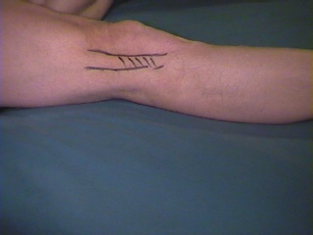

If the athlete presents early with the injury – simple anti-inflammatory measures such as regular ice massage of the painful spot, oral NSAID and exercises to stretch the ITB and modification of the training activity may allow the injury to settle. If presenting late or with persistent symptoms physiotherapy referral to physiotherapy is appropriate. Ultrasound treatment to settle the inflammation, stretches and friction massage of the ITB is usually given. Alternatively a little steroid of your choice infiltrated around the ITB may be very effective – Its what cured mine when all other treatment failed.
Recurrent cases need a biomechanical assessment with a view to correcting any foot problems. A chiropodist, podiatrist or physiotherapist with a biomechanical interest and skill should be consulted.
- John, aged 13, is brought by his very anxious father. John is a very promising rugby player. Unfortunately this season he has had to miss quite a lot of training due to a painful right knee. He points to a tender swelling below his kneecap.
Osgood-Schlatter’s disease is a common overuse problem in active adolescents. Left to their own devices they will work within the limits of their symptoms and time will resolve the problem as the epiphysis closes. Often here the problem is managing the parents or coach who what something doing. No treatment is necessary or appropriate here. Occasionally a late complication of OSD is failure of the epiphysis to close with continuing pain and swelling. This does not appear to be activity-related. A friendly orthopod will be pleased to pin the epiphysis for your patient
- The solicitor we encountered earlier has made good progress following your earlier excellent management and continues to train for his first London marathon. He is now at peak mileage with one month to go before the event. He is running 65miles/week at present. Unfortunately he is troubled by sore Achilles tendons for which he is requesting treatment.
A really good resource for doctors and more importantly patients is the sports medicine advisor site at the university of Michigan. Check out the section on Achilles tendon problems. Use the index to find advice on lots of other sports injuries.
- A 30 year old secretary has recently returned to tennis after a long absence due to family commitments. She has rediscovered some form and has done rather well in the local league. Unfortunately she has found her elbow has become very sore after a weekend with two games on the Saturday and wallpaper stripping in her dining room on the Sunday.
This patient illustrates the combination of work, sport and DIY activity leading to breakdown and injury. Without the DIY the problem would probably not occurred. You just can’t find the tradesmen these days though.
- The 14 year old girl you previously advised to cut down her running (due to knee pain) has been swimming three times a week to maintain her fitness. Sadly she is finding that breaststroke is making her knee increasingly sore and front crawl is hurting her right shoulder.
Patients with patello-femoral pain will find breast-stroke painful and they should avoid it until the muscle imbalance is corrected. Shoulder symptoms are common in swimmers. Overuse injuries to the rotator cuff are not uncommon with front crawl and butterfly strokes
- Eddie is a big lad for 11 years old. This may be why he has been put in the front row of the under 12 rugby team at his new school. After four matches he has developed pain between his shoulder blades. He thinks it happened going down for a scrum in the last match.
- Darren is a long lanky 16-year-old who wants to bowl as fast as his famous namesake. After six matches this season he has had increasing post match backache.
Two potential back problems here. Remember Scheurmann’s disease – osteochondritis of the vertebrae. An X ray is appropriate to exclude this.
Fast bowlers are prone to a stress fracture of the pars interarticularis of lumbar vertebra. The reasons for this are complex and are probably related to their bowling action and how much they extend and rotate their lumbar spines during delivery. Rest then rehabilitation is the only management strategy - to allow the injury to heal.
For a leaflet on sports injuries go to: http://www.arc.org.uk/about_arth/booklets/6042/6042.htm

Sport, joints and osteoarthritis
Many patients and doctors alike are concerned that habitual sporting activity, especially running, may damage joints. Thankfully long term epidemiological studies of athletes have yielded the answer. Perhaps not surprisingly, the answer is “It all depends on your joints”. Our joints were designed by natural selection to enable us to hunt animals on the plains of Africa many years ago. In other words our legs were meant for running on.
The articular cartilage depends for its nutrition on synovial fluid. Synovial fluid production is enhanced by joint motion, particularly motion that employs the full range of joint movement. As Pascal observed in the 17th century, “Our nature consists in movement – absolute rest is death”. Whether he was referring to the joints I am not sure. However, it is true to say that inactivity is more often the “death of joints” than activity.
A perfectly normal joint will not be damaged by habitual running activity. Sadly athletes are not always equipped with normal joints. In fact some sports appear to attract athletes with certain joint abnormalities e.g. hypermobile joints and gymnastics. With abnormal joints the story is different. Biomechanical abnormalities, flat feet, knock knees and legs of different lengths are clearly at increased risk of damage and early degenerative change. Fractures or dislocations that lead to joint mal-alignment or damaged articular surfaces may, similarly, lead to early joint degeneration.
A typical scenario is the knee that had a menisectomy, or two, 20 years ago when its owner sustained a meniscal tear playing rugby. After retirement from rugby said owner then takes up running to keep fit. Finding this activity enjoyable and therapeutic in a stressful lifestyle he trains for marathons until his knee begins to degenerate in the absence of its menisci. (Before you ask this knee is not the property of the author but a close friend!) Similar stories are heard from athletes that have sustained cruciate ligament injuries playing soccer, rugby or hockey.
So you now have the information to advise your patients. If the joints are normal carry on running. If not, non-weight bearing sport such as swimming, cycling and rowing would be kinder on the joints. For those who cannot possibly refrain from running, (and there are many of us about) buying the most shock absorbing shoes and equipping them with extra shock absorbing insoles is good advice. Running on softer surfaces and avoiding tarmac is sensible. Using weights to build up strength in the muscles around the affected joint will also aid shock absorption and reduce joint damage. Lower mileage and more cross-training will also help.

The things runners do – and a bit of injury prevention

In social science researchers interested in the cultures of more primitive societies than our own indulge in something known as ethnographic research or “going native”. Sparing no thought for personal safety your author has spent the last 21 years “going native” in the company of runners, swimmers, cyclists and triathletes. My observations may help you in managing your patients who also have these primitive urges to exercise habitually.

The nature of athletic training requires repetitive and incremental increase in workload. The prudent athlete will limit his increments to 10% per week with a day off every week and have an easier workload every third week to allow recovery. The prudent athlete is, unfortunately, a very rare species and subject to all sorts of influences, whims and fancies. A week’s holiday can be seen as an opportunity to double the training mileage. The first fine weekend in spring when the weather permits the wearing of shorts can induce a desire to run twice as far as anything previously attempted. The London marathon acceptance arrives in the Christmas post and can lead to a sudden burst of enthusiasm that results in Achilles tendinitis by the New Year. I have even heard runners boasting, “My Achilles tendons are sore”, as evidence of the mileage they are putting in.
Some runners seem to take the word repetition to heart and repeat the same circuit day in, day out. Running on roads and pavements means running on a cambered surface. Road runners, for safety reasons, run towards the oncoming traffic. Many miles on the same, hard, cambered surface has the same effect as running with a leg length discrepancy of an inch or more. The “downhill” leg will be subject to excessive stresses on its lateral side exposing it to the risks of trochanteric bursitis and ileo-tibial band syndrome. The simple suggestion to run the circuit the other way round may be all that is needed to cure the problem. Once the injury is resolved variety should be encouraged.
Regular training of a muscle leads to increased muscle bulk and tone and also, therefore, some tightening and shortening. Tight muscles and their tendons are injuries waiting to happen. The prudent athlete will incorporate regular stretching of the trained muscles into their training programme. However, you know what I said about prudent athletes. I have tried to persuade my running colleagues to stretch before we set off and after we finish but you get the distinct impression that they think stretching is for girlie whimps.
Runners are also very economical with their sporting equipment. Of all the sports running requires the least outlay on tackle. You would think they could shell out for some decent equipment. A decent pair of shoes is all that is absolutely essential. Unfortunately the shock absorbing properties of a running shoe deteriorate over time and shoes need to be replaced frequently. Some authorities say that an injury is an absolute indication for a new pair of shoes. The prudent athlete will therefore replace his shoes frequently. Sadly again the average runner will be more prudent with his money than his body and run in the same shoes until they fall apart.
These self-destructive tendencies are not related to levels of intellect. I have observed the same in groups of sporting doctors when gathered together in one place for a course on sports injuries. The urge to race each other between the end of the afternoon session and dinner is quite irresistible it seems or, perhaps, it is related to the altruistic urge to provide clinical material for the after dinner session.
I hope this pioneering research will give you some insight when the injured runner turns up in your surgery. Do treat him gently it might be your author.

A formulary for treatment of musculo-skeletal injuries
You will have noticed that we have mentioned drugs very little on this course. This is because we have come to believe that drugs have a very limited role in the management of the conditions we have been discussing, and thinking in terms of drugs can divert attention from optimal management of the problem. Prescribing drugs is a sophisticated medical skill. However, to quote Maslow again, “If the only tool you have is a hammer then you tend to treat every problem as a nail”
There are, of course, useful drugs for specific situations and it seems appropriate to put them in a short formulary along with other options for achieving the same outcomes.
Analgesia
Simple, rapid and very effective analgesia for acute musculo-skeletal pain can be provided by anyone who has access to a freezer . Icepacks are by far the most important analgesics in this area of medicine. Crushed ice in a plastic bag, frozen peas, wheat bags or gel packs (the latter two can also be microwaved to provide heat) will do. Remember to protect the skin with a layer of oil or a towel to prevent ice burn. Ice provides very effective short duration analgesia and obviously needs frequent reapplication. Ice also reduces swelling when applied early to an injury.
Aspirin, paracetamol or ibuprofen (low dose) are effective analgesics with a slower onset and longer duration of action than ice. They are obviously more convenient especially for overnight analgesia. For very severe acute pain from injuries such as fractures and dislocations intra-muscular diclofenac is the drug of choice. It is very effective and free from all the problems associated with opiates – side effects, addiction and abuse potential, legal constraints and in the unlikely event of an injured athlete returning rapidly to competition most opiates are banned by the sport governing bodies. This also applies to many weaker, orally administered opiates – so don’t risk a failed dope test.
Diclofenac and Ibuprofen – high dose are effective anti-inflammatory drugs. Ibuprofen has the best safety profile – especially relevant for the older patient who may have other pathology – and if used at higher doses. 600mg qds is as effective as any other NSAID. Evidence that the newer NSAIDS (Coxibs) are effective is accumulating. They appear to be safer from the gastro-intestinal point of view however there is concern about potential increased risk of cardiac problems. In view of this and their expense there is no indication as yet to rush to prescribe them.
Amitriptyline is a wonderful drug with many useful effects, lots of side effects and is a major hazard in overdose. For chronic pain that is disturbing sleep and especially in pain of neural origin it is far more effective than opiates and at a dose of 25mg at night probably has fewer significant side effects. Other tricyclics share these properties.
Local heat application is very effective for reducing the discomfort of muscle spasm. Wheat bags and gel packs can be warmed in the microwave, can be moulded around the painful body part and provide comfort especially at night. The drugs used as muscle relaxants are generally not very effective or in the case of benzodiazepines have troublesome side effects and addictive potential – they should be avoided.
Injectable depot steroid preparations are very effective agents for localised chronic inflammatory lesions of the joints and soft tissues. They can be administered with or without local anaesthetic are well tolerated, easy to administer and safe

A Brief Musculo/Skeletal Assessment Guide for GPs
The famous “GP quickie” – Richard’s guide to musculo-skeletal examination.

Introduction
The leaflet certainly doesn’t aim to provide comprehensive instructions for musculo-skeletal assessment, but will hopefully enable GPs to distinguish between common complaints in a limited time frame. (Once ref flag factors are eliminated).
Without wishing to state the obvious, the most important part of any assessment is looking and, therefore, undressing the appropriate area is essential.
The subjective history can be streamlined to find aggravating/relieving factors which can give huge clues to diagnosis, even before the objective assessment.
Knowing your dermatome referral area is necessary to save time and embarrassment i.e., shin splints referred from the hip!

Lumbar Spine
If the patient complains of leg symptoms refer to the dermatome section to give a reasonable assumption at which level the lesion is, i.e. lateral calf numbness/P+N/pain=L5 nerve root. (However remember a high lesion can affect lower nerve roots!).
Subjective Examination
The lumbar spine normally gives pain during prolonged sitting, lifting and stooping. Generally pain upon walking tends to originate from the hip, spinal stenosis or circulatory disorders. For objective markers use functional levels to assess improvement i.e., time to dress, sit etc without pain.
Objective Examination
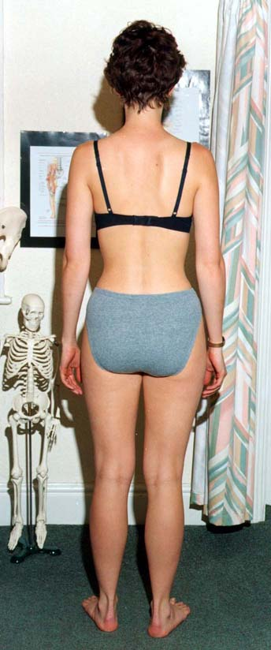
Leg length discrepancies are best judged
in standing – use different sized heel raises/arch
supports to correct inequality.
Check
Correctable scoliosis, increased thoracic
kyphosis tone/bulk loss and general posture.

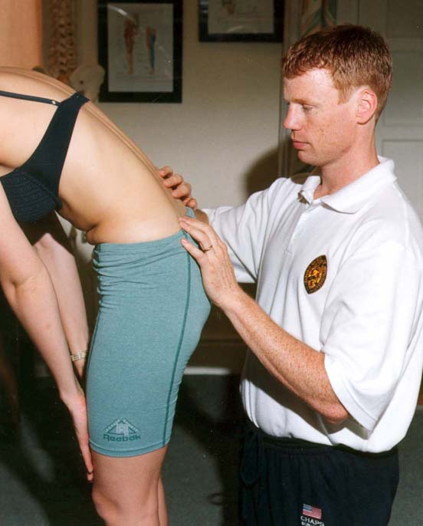

Flexion
Getting the patient to touch their toes will measure hip/neural flexibility not lumbar movement. For a more accurate measurement palpate individual segmental movement.
Check
Correct pelvic tilting rhythm

Lumbar Spine (cont)
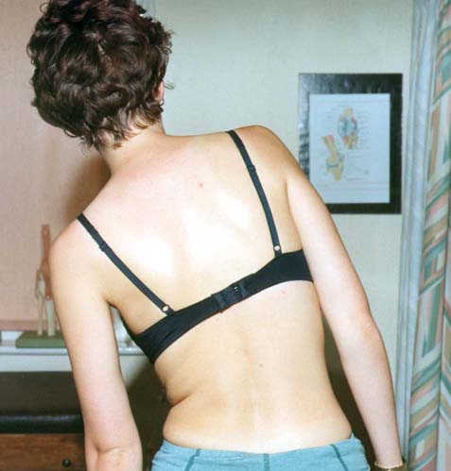

Side Flexion
Measure hand to knee distance
Check
Quality of each segmental movement

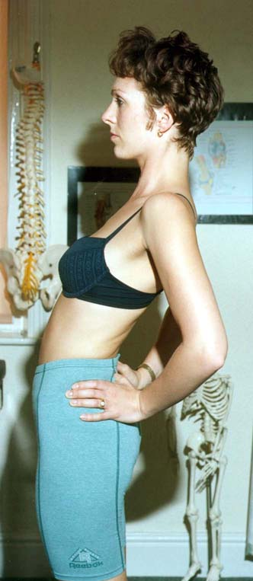

Extention
Often restricted but sometimes relieves symptoms.

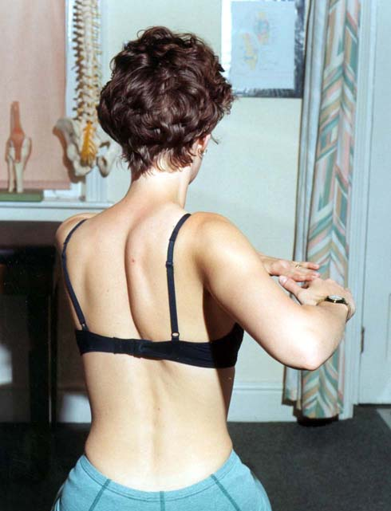
Rotation
Best measured in sitting to eliminate Leg/Hip rotation.
Check
Asymmetry

Lumbar Spine (cont)

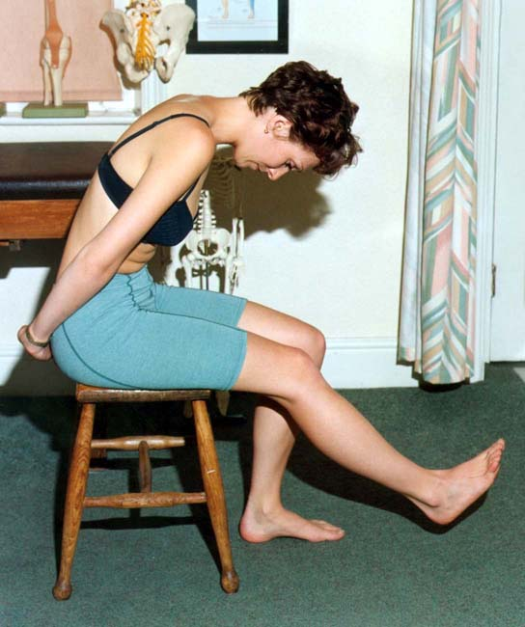
Slump Test
This is quite an aggressive test to check neural length. Problems driving are often reproduced.
Check
Good to affected. Add in ankle dorsiflexion and knee extension slowly. Compare this test to SLR i.e.. If slump test negative but SLR 30 deg positive!!

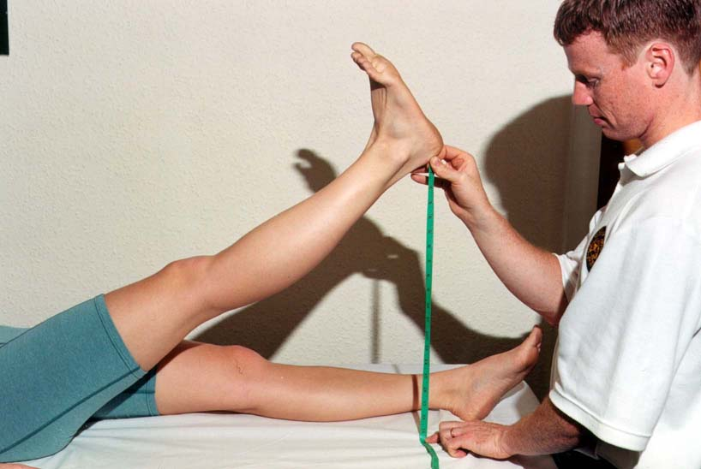

SLR
Measure heel to plinth with knee locked in extension and ankle plantargrade.

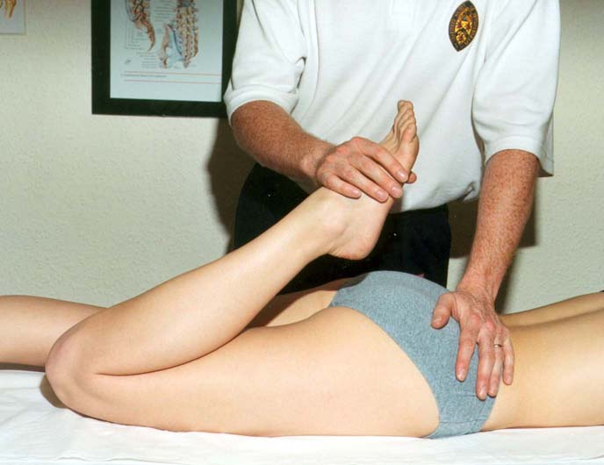

Passive Knee Bend
To check femoral nerve length. Add in foot movements to reproduce the patient’s pain.

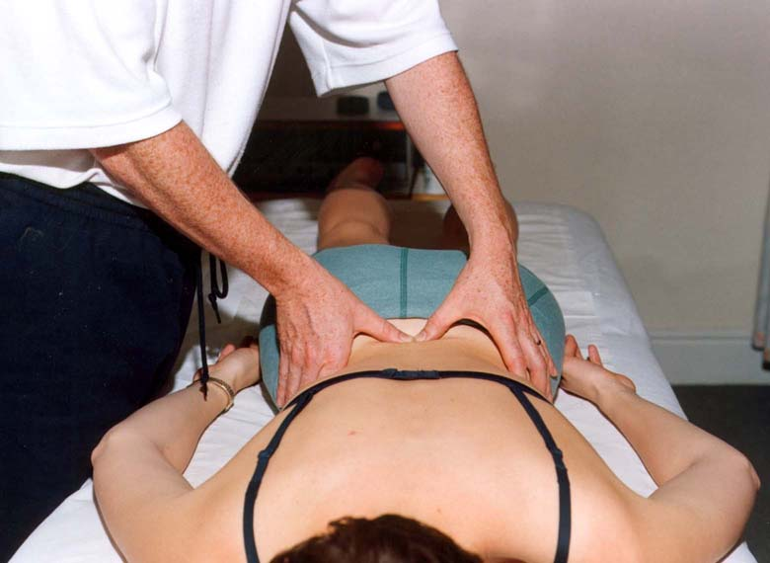

Finally, palpate to pin point the local lesion start lightly

HIP
The hip classically refers pain into the anterior aspect of the thigh, around the SI joint, groin and occasionally the knee, anteriorly. The patient normally complains of pain after a certain distance of walking, transferring out of low chairs and twisting.
NB Capsular pattern of hip = ↓ Medical rotation, flexion, extension and abduction.

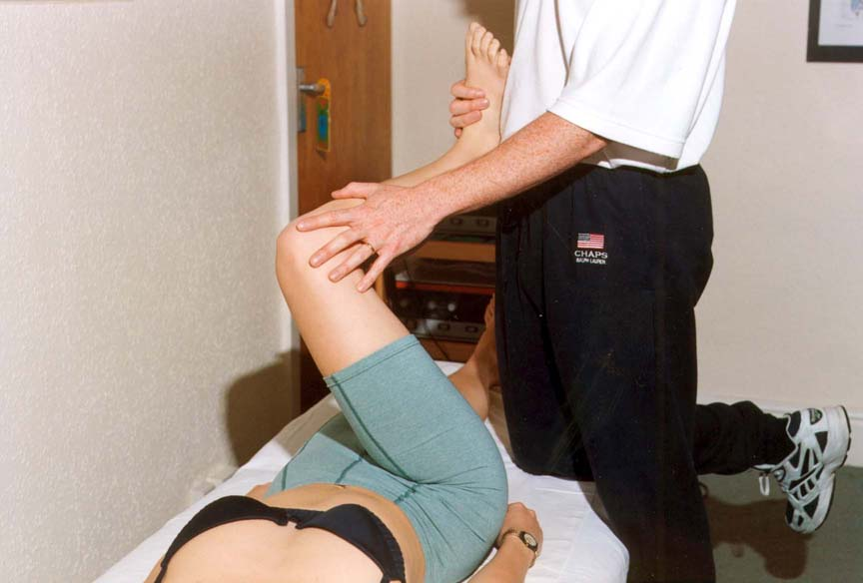
Objective Examination Look for asymmetry in standing, muscle bulk loss especially gluteals, quads and hamstrings

Hip tests – Flexion, medial rotation with abduction.
Bend the knee as far up to the chest as possible and while keeping the ankle outwards, roll the knee towards the opposite shoulder.

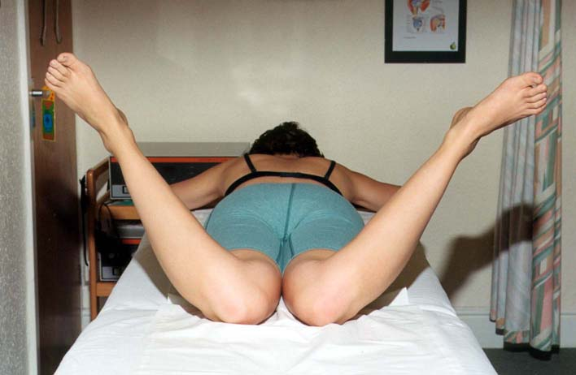
Prone Test
The test gives an immediate comparison of medial rotation (the most obvious discrepancy in hip pathology). To eliminate back involvement test one hip whilst stabilising the pelvis.

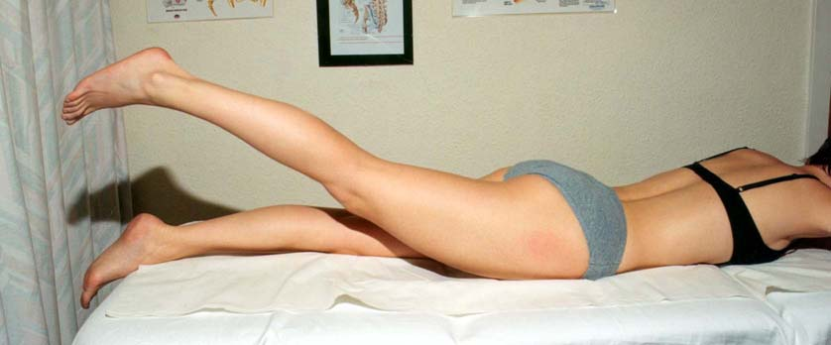
Still in prone check hip extension. NB. Place hand upon lumber spine to prevent trick extension movements. Check gluteal/hamstring contractions.

Hip (cont)
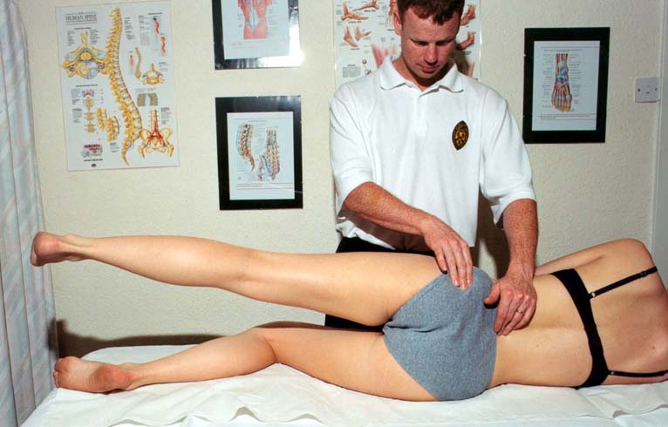
In side lying check hip abduction, gluteal (medius and minimus) and Tensor fascia lata contractions

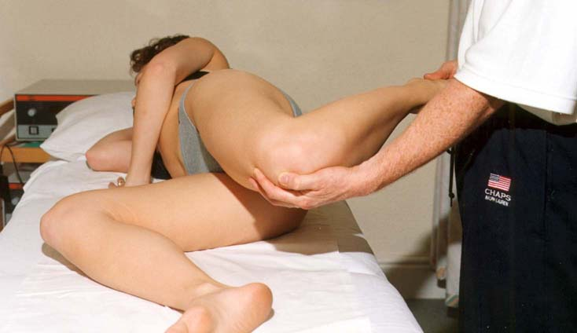

Still in side lying Rectus femoris flexibility i.e., if pain increases with increased knee flexion = R.F lesion. If no increase = PSOAS lesion. NB. Hip extension can also be measured in this position

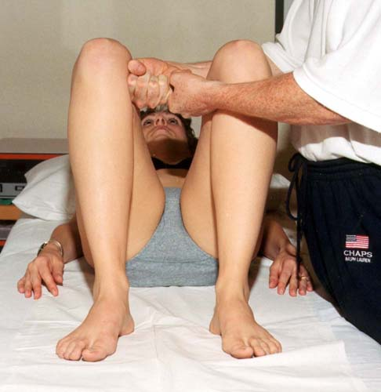

Knee Squeeze test
Abductor contractions open reproduce pain in the groin region.

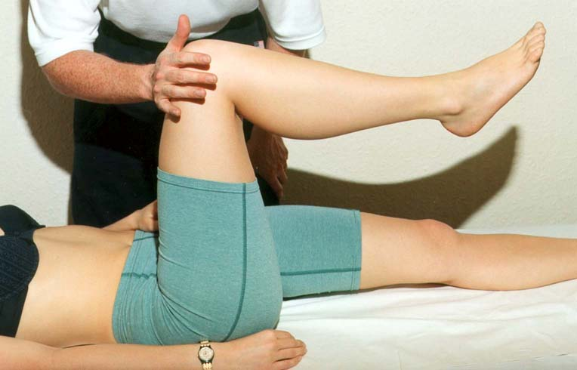

PSOAS Test
Gently push the knee downwards against the patients resistance.

KNEE
The knee despite being the most complicated joint in the body tends to refer its pain locally. As a rule symptoms around the knee can originate from the patello-femoral joint, giving way of the knee can be an anterior cruciate ligament rupture or unstable PF joint, locking and clicking could be meniscal in origin but be careful to exclude the hip joint.
Look for effusions, bulk loss especially medial quadriceps, deformity valgus or varus. Check asymmetry in feet arch heights

Objective Examination

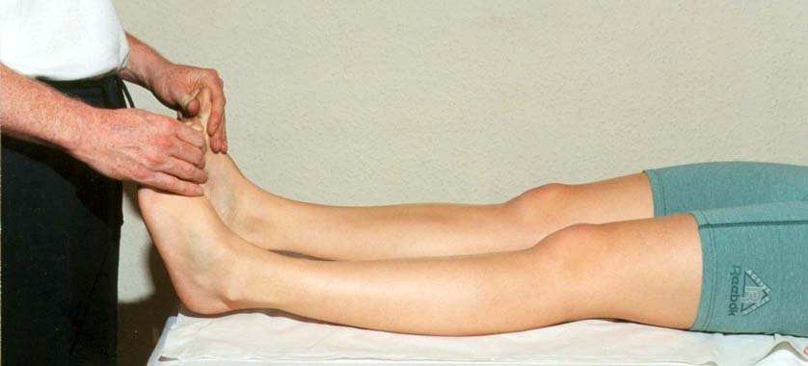
Extension Test
Picking up the big toe can compare full or hyperextension (? ACL). Blocking could be meniscal.

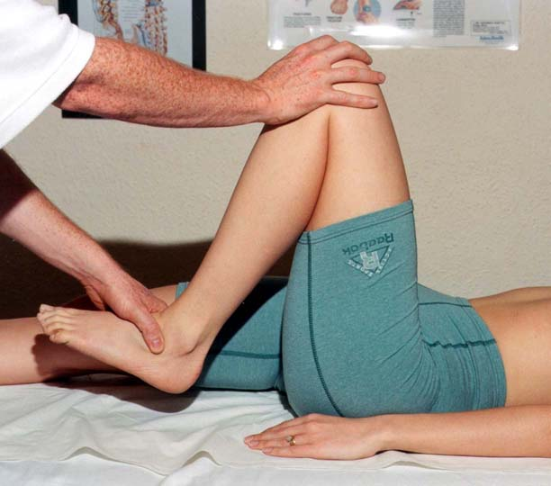

Flexion – heel to buttock
Can be checked with the tibial rotation to eliminate meniscal/coronary ligament involvement (see below)

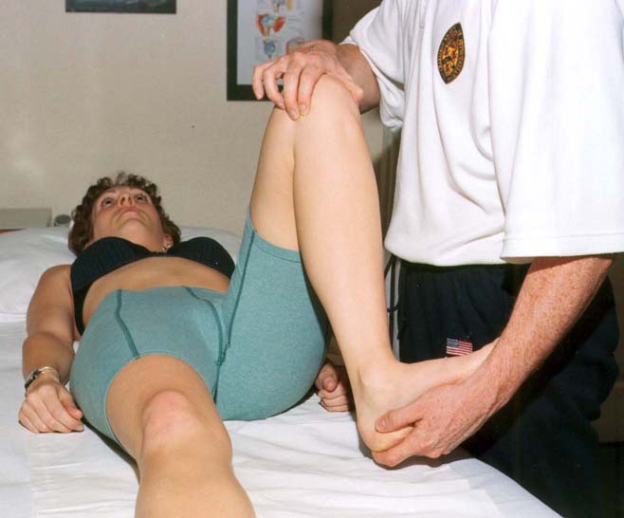
Placing the fingers on the joint line can detect meniscal movement and localised pain is often indicative of a lesion.

Knee (cont)
Knee Ligament Tests

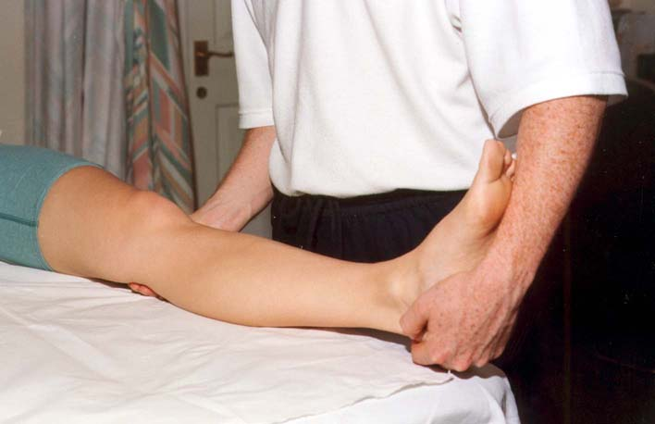
M.C.L
Hold the knee in full extension, preventing leg rotation, and gap the knee medially to check the ligament. Also check in 30 deg flexion.
NB. Upon palpation most lesions lie at the proximal attachment.

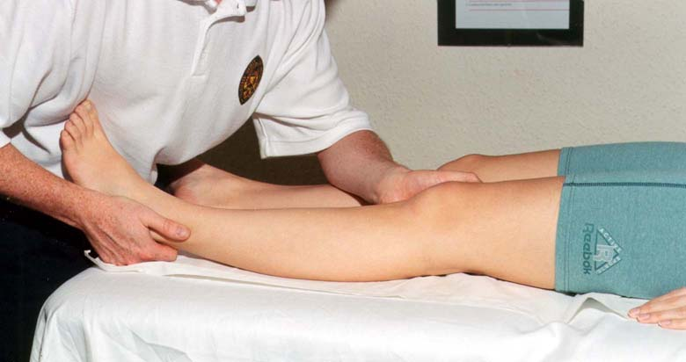

L.C.L
As the MCL test but gapping laterally. Only in full extension.

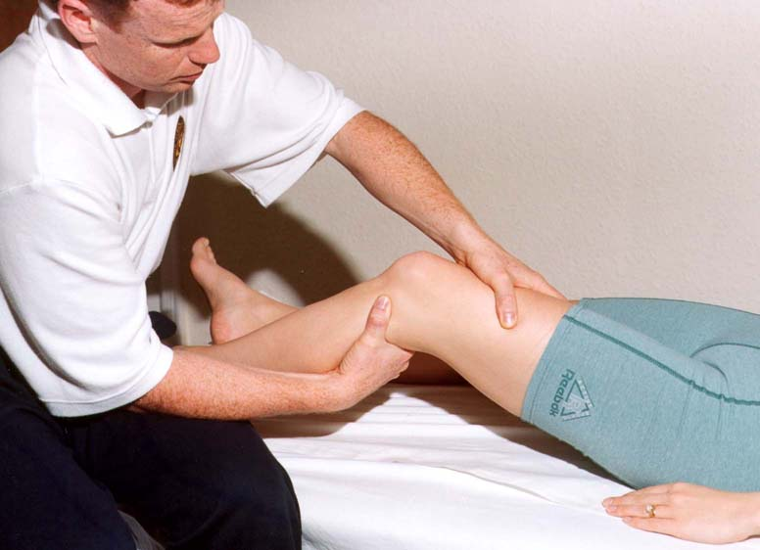
A.C.L.
Can be checked at 90 deg flexion (anterior draw test) or approximately 30 deg flexion (Lachman’s test) LEFT. The aim is to shift the tibia forwards upon the femur to reproduce instability (better simulated by the pivot shift test).

Knee (cont)
Knee Resisted Tests

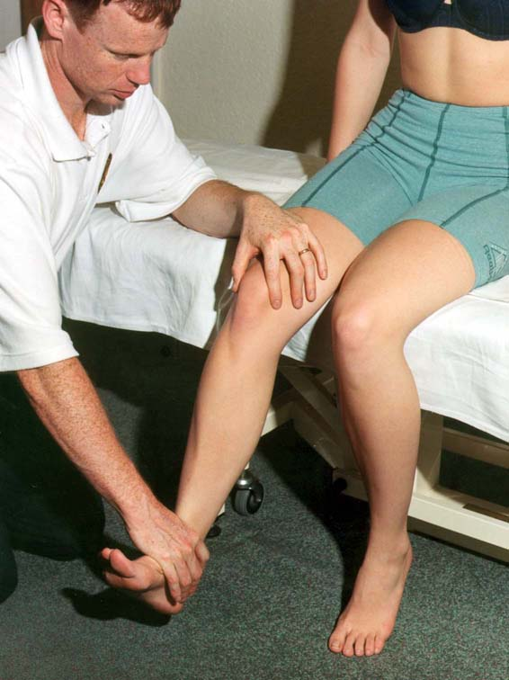

Ask the patient to push against your hand whilst palpating the PF joint.
NB. If full extension is possible ask the patient to slowly lower the leg, still against your resistance (eccentric loading is extremely difficult for a pathological problem at the quadriceps or PF joint).

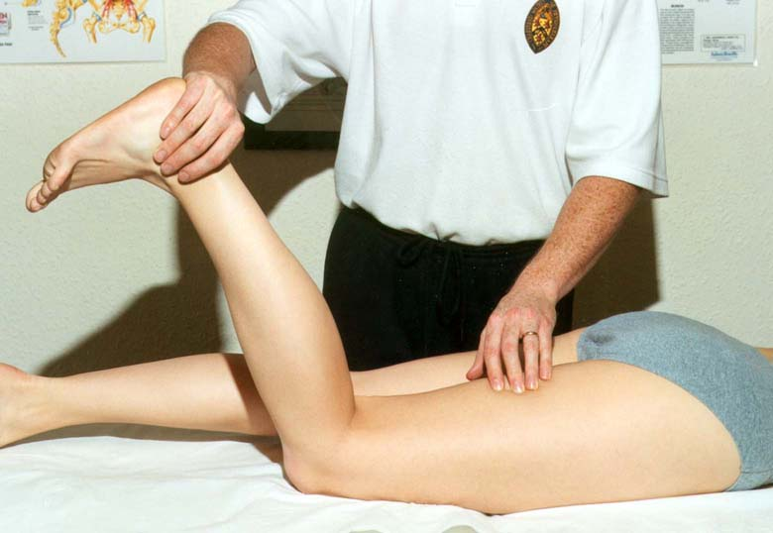

Hamstring
Against resistance test both concentric and eccentric contractions. Palpate for lesions.

SHOULDER
When assessing the shoulder joint it is important to remember that complete movement includes the Gleno-humeral, (GHjt) sterno-clavicular, acromio-clavicular, scapular-thoracic and upper thoracic joints. The Gleno-humeral joint mainly refers to the C5/6 dermatome but pain is generally reproduced in the deltoid insertion and biceps regions. Pathology can be roughly divided into 3 categories.

- Capsular pattern - ↓ lateral rotation, Abd, and flexion in the G/H joint.
- Rotator cuff lesion – painful arc especially at 80 – 120 deg Abd. Often increased pain upon descending and upon resisted static movements.
- Bursitis – painful arc but the same active as passive
Look for asymmetry in bulk, swelling, shoulder and neck position.

Objective Examination
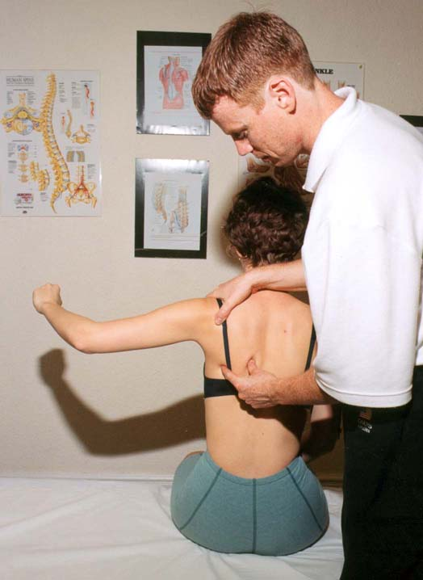
Gleno-humeral movement
Fix the shoulder girdle movements with one hand over the acromion and the other at the inferior angle of the scapula (up to 80-90 Abd possible).
NB. Check for early scapulo-thoracic movement.

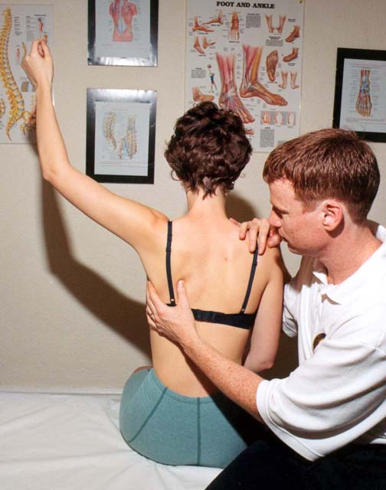

Abd between 90 and 150 deg mainly takes place at the scapulo-thoracic junction. External G/H joint rotation should take place at this point.
NB. Also check the normal pattern in reverse when descending.

Shoulder (cont)
Static Resisted Rotator Cuff Tests

NB. Static tests: keep patients elbow at their side. Always re-test to confirm diagnosis.
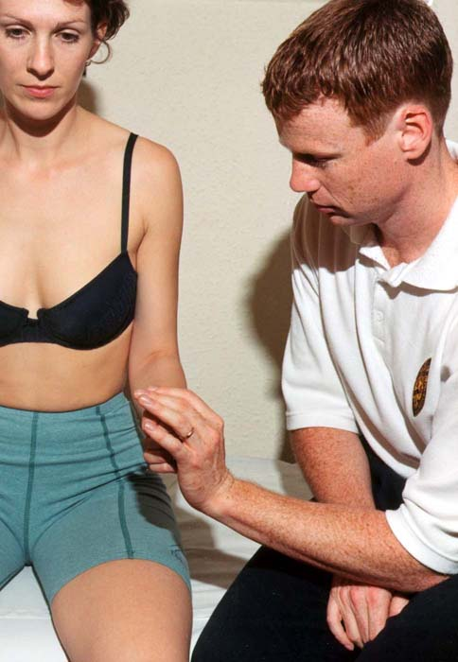

Lateral rotation (infraspinatus)
Elbow bent to 90 deg. Ask patient to push their wrist outwards but keeping the elbow by their side.

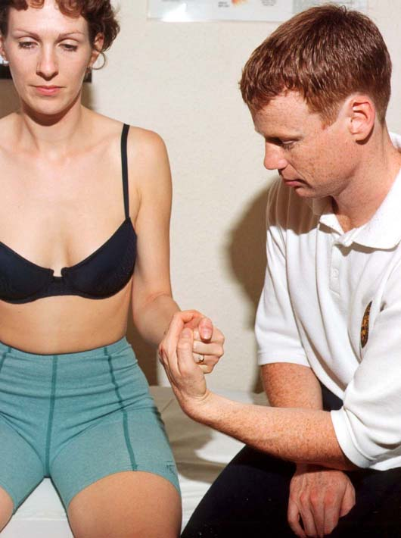

Internal rotation (subscapularis)
Pain normally felt over anterior joint.
Ask patient to pull inwards from their wrist.

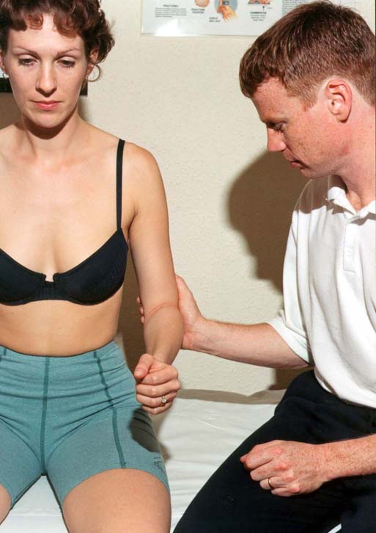

Abduction
Suspraspinatus is the most commonly damaged rotator cuff muscle and works to initiate abduction. Ask patient to push outwards at their elbow.

Shoulder (cont)
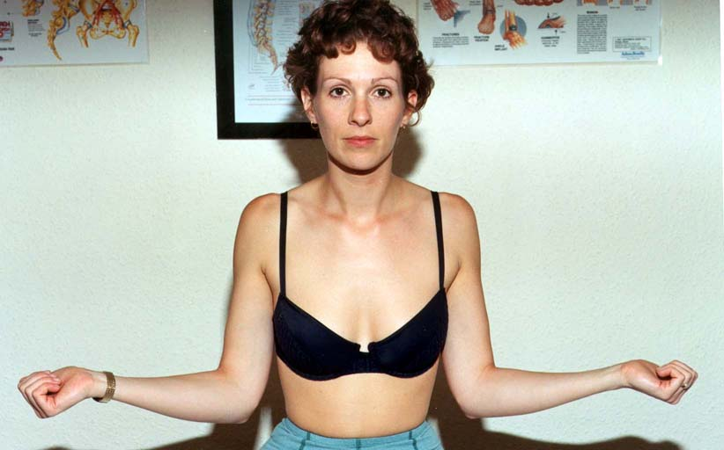

Lateral Rotation
Compare one side to the other

Scarf Test (arm across chest)
Generally used to test the acromio-clavicular joint (tends to refer locally and tender upon direct pressure).

Feel for – Temperature changes
Local tenderness
Swelling
Altered sensation in arm

NECK
The neck can refer to the shoulder point (C4) down the arm (C5-T2) and into the scapula region (Cloward’s sign).
The patient will often complain of problems during sleep, driving and in occupations involving screen or paperwork.
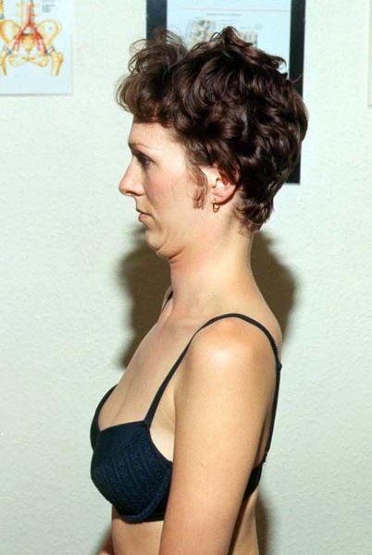
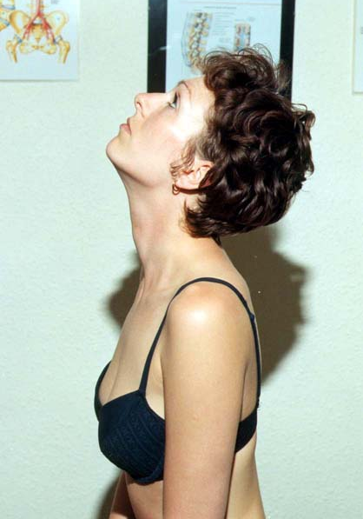
Objective Examination

Retraction Extension
Observe if the patient starts Normally occurs in
from a chin poked position (Common) the upper cervical Segments
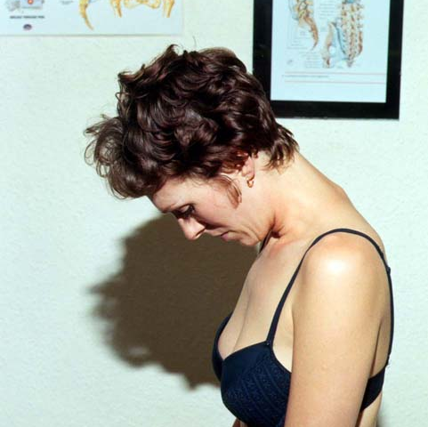
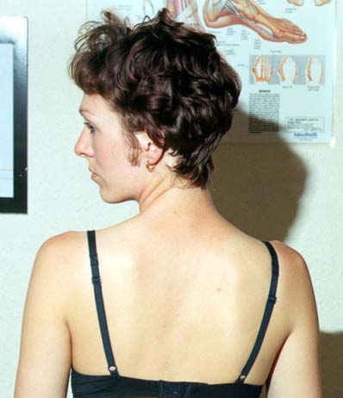

Flexion Rotation
Observe any discrepancy at the cervical/thoracic junction Observe any discrepancy
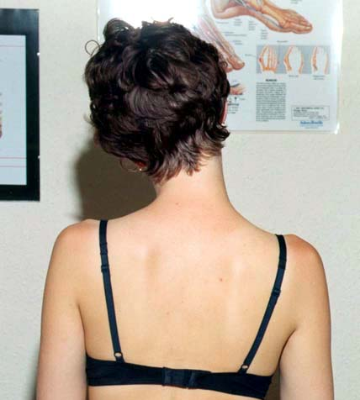

Side Flexion
If restricted can often affect sleeping.
Palpate for focal tenderness
Postcript
The Dynamic body tutors hope you enjoyed the course as much as we did and that you and your patients will continue to benefit in the future from our work together.
We may well contact you in the future for a late evaluation exercise on the effectiveness of the course.

Adrian Dunbar
Richard Kunz
Mark Brooke
Jamie Bell

